


Cloud Security Incident Management

Team Members

- Ahmed Taha
- Hamed Nabil
- Mohamed Amin
- Mohamed Mahmoud Taher
- Remon Nabil

Index:

Project Description………………………………………………………… 4
Project Plan………………………………………………………………… 5
Project Milestones and Deliverables……………………………………… 6
Introduction to cloud Security……….…………………………………… 7
AWS cloud vulnerabilities……………………………….………………… 23
AWS cloud IR plan……….……………………………………………….... 28
AWS cloud DR……………………………………………………………… 35

Project Description:
- Overview:
We propose to create an Incident Response plan for AWS cloud environment and Disaster Recovery strategy for AWS-Only Architecture: Primary Region (Active) + Secondary Region (Passive DR), while using AWS specific services S3, RDS, EC2, route53,

- Description:
A comprehensive incident response plan and business continuity strategy using AWS cloud environment for both production (main/active) and Disaster Recovery (passive DR in a secondary region) while focusing on AWS cloud security and recovery strategies.
Identify and assess AWS cloud vulnerabilities, define incident response plan and communication protocols, develop a business continuity plan, disaster recovery strategy, backup and recovery procedures.
This plan follows NIST SP 800-61 and is customized for cloud (IaaS/PaaS/SaaS). It applies to all cloud accounts and workloads, all content is practical, actionable, and based on industry standards (NIST SP 800-61 Rev. 2, CSA Cloud Controls Matrix, and cloud-native best practices).

Objectives:
- Identified and assessed AWS-specific vulnerabilities in a multi-region active-passive setup
- Conduct Risk Assessment report
- Create Incident Response Plan for AWS Cloud including Incident Response Phases, Roles & Responsibilities
- Define Communication and Escalation Protocols, and External Notification.
- Develop business continuity plan and Business Impact Analysis (BIA).
- Develop disaster recovery strategy for AWS cloud Multi-Region approach.
- Define Backup and Recovery Procedures for AWS cloud.

Project Plan:
Week 1: Cloud Security Vulnerabilities:
- Task 1: Introduction to the cloud and Identify and assess cloud-specific vulnerabilities and document the findings.
  - Duration: 3 days
  - Dependency: None (starts the project)
- Task 2: Cloud security vulnerabilities report.
  - Duration: 2 days
  - Dependency: Task 1 completion
- Milestone 1: Approved Presentation on cloud security risks

Week 2: Develop an incident response plan tailored for AWS cloud environments including roles and procedures.
- Task 3: Cloud incident response plan document.
  - Duration: 4 days
  - Dependency: Task 2 completion
- Task 4: Communication and escalation protocols
  - Duration: 2 days
  - Dependency: Task 3 completion
- Milestone 2: Initial draft of IR plan
  - Basic version of the plan.

Week 3: Business Continuity and Disaster Recovery
- Task 5: Develop a business continuity plan and
  - Duration: 3 days
  - Dependency: Task 4 completion
- Task 6: disaster recovery strategy for cloud environments
  - Duration: 3 days
  - Dependency: Task 5 completion
- Milestone 3: Business continuity and disaster recovery plan
  - Backup and recovery procedures.

Week 4: Final Report documentation and Presentation
- Task 7: Compile the incident response plan and business continuity
- strategy into a final report and present the findings.
  - Duration: 4 days
  - Dependency: Task 6 completion
- Task 8: Final IR plan with cloud security and recovery strategies.
  - Duration: 3 days
  - Dependency: Task 7 partial completion
- Milestone 4: Final Documentation
  - Presentation slides and notes

Project Milestones and Deliverables:
- Milestones:
- Approved Presentation on cloud security risks
- Initial draft of IR plan
- Business continuity and disaster recovery plan
- Final Documentation

- Deliverables:
Week 1:
  - Task distribution
  - Introduction to cloud
  - AWS cloud vulnerabilities
Week 2:
  - Basic version of the plan.
  - Brainstorming for DR using multi cloud vs single cloud vendor
Week 3:
  - Business continuity and disaster recovery plan
  - Backup and recovery procedures
Week 4:
  - Final IR plan with cloud security and recovery strategies
  - Final Documentation and Presentation slides.

What is cloud storage?
Cloud storage is a service that allows you to save, access, and manage digital data through online networks rather than on a local device or physical server. It’s a virtual space where you can upload and access files like documents, images, and videos from any device using cloud-based servers.
Many businesses use cloud storage solutions to manage important documents and share them with employees and stakeholders. In fact, the cloud has become a solution for reducing the complexity of business content management. According to a Box-sponsored IDC white paper, 39% of organizations say that difficulty finding data or documents is one of the biggest challenges preventing them from working as efficiently as possible.
Cloud storage examples and use cases
Cloud storage has both professional and personal applications.
Cloud storage use cases | Examples
Website hosting | Website hosting services store all your media, posts, and other site data in their  cloud databases, so that content is readily available when you need to co-edit a post or  when a user lands on your site.
File sharing | Organizations use cloud storage to save their documents and share them with collaborators  like employees and business partners. By having the right credentials and  following link sharing best practices, authorized users can securely access and  download your files online from anywhere in the world.
Virtual desktop hosting | Virtual desktop infrastructure (VDI) is helpful for companies with large  distributed workforces and bring-your-own-device (BYOD) policies because it  provides additional security for business data. VDI stores all of a user’s desktop  information as a virtual machine (VM) in the cloud, reducing server maintenance and  overhead costs for your company.
Online backups | You can create an additional copy of your mission-critical business data and store it in the  cloud. You’ll be prepared for outages, natural disasters, and other emergencies that could  halt your operations. Many cloud backup solutions automate the process, keeping your  data always up to date when you need it.

What is Cloud Computing?
In the present world, the concept of cloud is no longer, hidden in obscurity. It has gained so much respect in terms of digital transformation that it now applies in everyday life. But here is a catch. The first one has to get a complete understanding of cloud infrastructure, its working, and the recent trends that will define the world of cloud computing.
Still, a long way to go, yet cloud computing services have now become an invincible part that everyone from a user to a business tycoon wants to avail themselves to ensure greater sustainability in their life (and not to forget their business).
In this guide, we will unravel some hidden and not-so-known facts about cloud computing. Moreover, we will also recognize how it will shape the future of working and living. Let’s go more deeply into the give exciting adventure!
Concept of Cloud Computing
First of all, what is cloud computing?
Technically speaking, cloud computing is the distribution of large infrastructural resources in digital format through the use of the internet for delivering a pool of hosted services for the customers.
In simple terms, cloud computing implies perfect felicitating on-demand computing services from storage to applications to networking. The only thing to keep in mind is the presence of a proper internet medium over the cloud through a payment processor called ‘pay as you go’.
Therefore one thing is clear: with cloud computing at the helm, customers can access five crucial aspects:
- Data Management
- Data Storage
- Devices
- Networking
- Internet & Other Online Services
Why is Cloud Computing Important?
If you think that cloud computing is just a trendy topic that attracts people only to store their photos and videos online, then you are binging on the wrong concept. It is a new business model that has changed the way of thinking among enterprises. Not only is it helping companies (large, medium, and small) for storing and accessing data easily; it is also aiding in the smooth functioning of their business operation.
Technology has enabled even a small business to excel perfectly in this competitive world. Today, every cloud-native application development company is implementing cloud computing to have wide appeal to their customers through the digital transformation of their business. There are several reasons which show that cloud computing is essential for the effective conduction of a business. It has been explained through the following steps:
I. High-Cost Effectiveness
From a business point of view, cloud computing has come as a game-changer as cloud consulting services are provided on-demand to the users. It implies payment is done only for what the users utilize through a subscription-based technology which negates other costs (like maintenance, labor, and purchasing).
II. Great Flexibility
If your business is experiencing continuous bandwidth; then it is time to switch to cloud computing. It will make resource management easier than ever. Just, you have to pay for resources per month and get access to the flexible packages (that include cloud storage and VPS providers)!
III. Full Data Recovery
There is no threat of data loss in the cloud platform as they are stored in multiple locations. Even if one server fails to function well, data is safe at other locations. The given service will be fruitful for small businesses that lack high-tech infrastructure and often face data theft.
IV. No Need of Maintenance
Maintenance is a state of concern for a traditional setup. However, there is no need for maintenance for a cloud computing environment. No other cost is involved as everything is handled by the service providers!
V. Perfect Digital Transformation
Every business today aspires to have a complete digital transformation. It includes fully digital migration of data from the current system to the cloud. It is often a costly method, but cloud computing allows seamless transition with no consequences and that too, with great ease.
Top Benefits & Drawbacks of Cloud Computing
The arrival of the cloud has transformed the way of conduction business. Numerous benefits come with the cloud. So before switching to it, one must get acquainted with the profits that one avails from the given technology.
i. Significant Cost Reduction
The basic financial principle is to earn more than spend. With cloud computing at the helm, there is no need to waste thousands of dollars on maintenance, upgrading technology, and purchasing software licenses. All these issues are taken care of by cloud-based apps just at minimum cost.
ii. High-Level Security
Cloud computing is more secure than an in-house computing system. It’s because cloud computing service providers work under strict scrutiny and are obliged to provide sufficient care to their customers’ info through employing full-time digital security person.
iii. High Reliability
The best part of cloud service providers is that they remain aloof because of redundancy. How? It’s simple! The data is stored not just on a single but across multiple servers. So, there is superb reliability in accessing data and services without any effect even from the occurrence of hardware failure.
iv. No Hardware Requirement
There will be no requirement for physical storage as everything will get hosted in the cloud. Furthermore, the provision of backup will boost the company’s prospects in case of a disastrous event.
However, with every advantage, there are some disadvantages associated with any technology, and cloud computing is no such exception.
i. Downtime: The Biggest Disadvantage
Downtime is the greatest threat to the popularity of cloud computing, and it means going down internet access. Robust data plans with cellular service help one to get internet access even during power shortages. But they have limited life, and there is difficulty in accessing cloud services after it goes out.
ii. Control Going Out of Hand of Users
When someone transfers all their services to the cloud, they also had over their crucial data in their hand. Companies with in-house staff may find it difficult to handle the issues that will ultimately lead to the enlargement of the current issue.
iii. Lacks All Crucial Features
There is a limitation with services available from cloud computing. Some service providers tend to offer only limited services compromising some limited features only. The only solution for the customers is to make sure, they check the facilities offered by the cloud service providers.
What are the types of cloud and their services?
An interesting part about cloud computing is that multiple types segregate and provide basic cloud facilities. Whether they work in the form of deployment or services, they offer you different levels of flexibility, management, and control.
In terms of deployment, it comes in four types:
a. Public Cloud
It is the sharing of all cloud resources such as memory, networking, CPU, and others on the public platform via the internet. Some notable examples are Amazon Web Services and Microsoft Azure.
b. Private Cloud
It is a privately owned system where 3rd party offers services with a high level of security, and sole control on the internet lies in their hand.
c. Hybrid Cloud
A combined form of the private and public cloud allows seamless working on a virtual private network to get an innovative business solution.
d. Community Cloud
They offer cloud services in the same industry working for similar goals. A community cloud environment is created after meeting the basic requirements that will boost up the performance.
Likewise, there are further types of cloud computing in terms of services that offer a solution to numerous problems. They are of three types:
a) Infrastructure as a Service (IaaS)
IaaS offers flexible cloud services by full virtualization of data and server storage to meet the demands of the customers and users alike. Its examples are Azure Virtual Machine and Google Cloud VM Instance.
b) Platform as a Service (PaaS)
PaaS creates a platform for offering multiple services starting from developing to the delivery of software services on an on-demand basis. It includes Google App Engine and Microsoft Azure.
c) Software as a Service (SaaS)
It is a fully-developed and robust cloud solution that does not require installation and can be downloaded directly through the internet. Example: Microsoft 365, Salesforce, and Google Apps.
Like cloud storage, cloud computing has virtually endless applications. Below are some common cloud computing examples.
Cloud computing use cases | Examples
Cloud-based communication platforms | When you send an email using a service like Gmail or Microsoft Outlook,  your message and attachments are stored in the cloud before arriving in  the recipient’s inbox. Messaging platforms like Slack and WhatsApp also use  the cloud to store conversations and media, letting users access previous  messages and files through the application.
Software as a service (SaaS) | Ranging from e-commerce to video conferencing, these SaaS applications  often offer desktop or mobile apps for convenience, but for the most part,  you can accomplish your tasks from a web portal.  Many cloud computing services also offer cloud app integration with  other platforms to streamline the experience and increase productivity.
Remote data analytics | Companies can perform data analytics off-site through cloud-based analytics  applications. Most cloud computing solutions provide user-friendly interfaces,  allowing you to easily generate detailed reports and create visualizations of  data to share with relevant stakeholders.
Website content | When someone visits your website and engages with your content,  cloud computing powers the interaction. Cloud storage supports  large file hosting on your website, but you need cloud computing to  make that content usable.  For example, in video streaming sites, all the video content is stored in the cloud,  but when a user clicks on a video, cloud computing operations run in the  background to access the data and play it.
Business management platforms | Business management platforms provide larger organizations with powerful  tools that house your organization’s data in one centralized place so  stakeholders can access the information they need to make informed  business decisions quickly and efficiently.  Common examples include customer management systems (CMS), enterprise  resource planning (ERP) software, and Intelligent Content  Management platforms.

Latest cloud computing trends in 2026
1. AI + Cloud Integration
Artificial Intelligence (AI) and cloud computing are no longer separate domains. Today, AI workloads are increasingly hosted and scaled on cloud platforms like AWS, Microsoft Azure, and Google Cloud. This integration allows businesses to train complex machine learning models, deploy natural language processing systems, and run predictive analytics without investing in expensive on-premises infrastructure.
For example, healthcare companies use cloud-based AI to analyze patient data, while e-commerce platforms rely on AI-driven cloud services to personalize customer experiences.
2. Serverless Computing Expansion
Serverless computing is revolutionizing how developers build applications. Instead of managing servers, developers simply write code, and the cloud provider handles everything else. Platforms like AWS Lambda, Google Cloud Functions, and Azure Functions are leading this transformation.
This model reduces costs, improves scalability, and allows developers to focus on innovation rather than infrastructure. Startups especially benefit from serverless computing because it lowers entry barriers and speeds up product launches.
3. Multi-Cloud and Hybrid Strategies
Gone are the days when companies relied on a single cloud provider. In 2026, multi-cloud strategies — using multiple providers like AWS, Azure, and GCP simultaneously — are becoming the norm. Hybrid models, which combine on-premises infrastructure with cloud services, are also gaining traction.
This approach prevents vendor lock-in, improves resilience, and allows organizations to optimize costs by choosing the best services from each provider.
4. Cloud Cost Optimization
As cloud usage grows, so do cloud bills. Companies are now focusing on cloud cost optimization — using analytics, automation, and monitoring tools to reduce unnecessary spending. Cloud FinOps (Financial Operations) has emerged as a specialized career path, combining finance and cloud expertise.
5. Cloud Security and Compliance
With increasing cyber threats and stricter data privacy laws, cloud security has become a top priority. Providers are investing in advanced encryption, zero-trust frameworks, and compliance certifications to protect sensitive information.
Industries like banking, healthcare, and government demand secure cloud solutions to meet regulatory requirements.
6. Edge Computing + Cloud Synergy
Edge computing brings processing closer to devices — think IoT sensors, autonomous vehicles, and smart cities. When combined with cloud computing, it enables real-time analytics and faster decision-making.
For example, smart factories use edge + cloud to monitor machinery in real time, while autonomous cars rely on edge computing for instant navigation decisions.
7. Industry-Specific Cloud Solutions
Cloud providers are increasingly offering industry-specific solutions. For example, healthcare clouds focus on patient data security, while retail clouds emphasize customer analytics. This specialization helps businesses adopt cloud services tailored to their unique needs.
8. Sustainability in Cloud Computing
Green cloud initiatives are gaining momentum. Providers are investing in renewable energy, efficient cooling systems, and carbon-neutral data centers. Sustainability is not just a buzzword; it’s a business requirement.
9. Cloud-Native Development
Cloud-native applications are designed specifically for cloud environments, using microservices, containers, and Kubernetes. This approach improves scalability, resilience, and deployment speed.
10. Quantum Computing and the Cloud
Though still emerging, quantum computing is being integrated with cloud platforms. Providers are offering quantum computing as a service, allowing researchers and developers to experiment without owning quantum hardware.
Conclusion
Cloud computing in 2026 is more than just storage and servers. It’s about AI integration, serverless innovation, multi-cloud resilience, cost optimization, security, edge computing, and sustainability. For students, this means exciting career paths and endless opportunities.
What is the difference between cloud computing and cloud storage?
Cloud storage is for data, while cloud computing is for processes. Essentially, storage in the cloud simply holds your data, while computing in the cloud allows you to do things with that data — such as analyzing information, generating reports, or automating digital workflows.
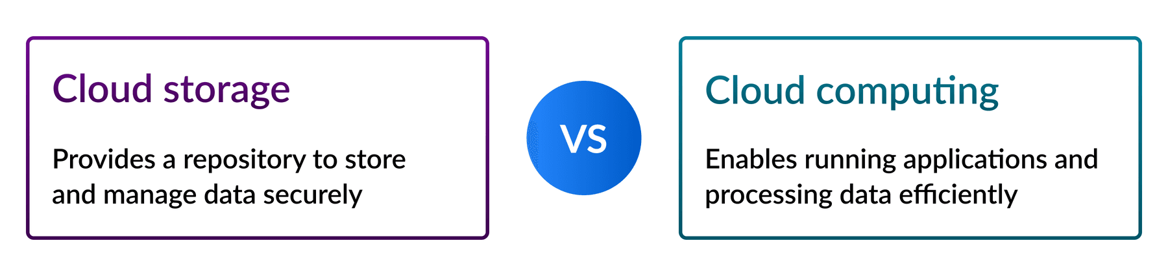
Aspects | Differences between cloud computing and storage
Application | Most cloud computing programs are specifically designed for business use,  while cloud storage is equally useful for both professional and personal needs.
Value | Cloud computing applications are active services, meaning you get value  from the server as you use it. Cloud storage, on the other hand, is passive.  All you need to do is choose a service with the right cloud storage capacity and add your data to it
System requirements | Computing requires significantly more processing power than storage.  Because computing solutions are generally web-based, they also require less hard drive space  than cloud storage, which may require you to download additional software.
Interdependency | Cloud computing and storage work together:  Storage relies on computing for processing data, and computing depends on storage to access, hold, and manage the data it works with.
Features | Storage solutions typically include features like data backup, encryption,  and easy sharing, while computing provides on-demand computing power,  application hosting, and real-time data processing.
Understanding the comparison of cloud storage vs. cloud computing can help you determine which solution would work best for your business and why. Let’s take a look at the key differences between them.
Similarities between cloud computing and data storage
Cloud storage and cloud computing both involve external servers, which can be anywhere. Cloud infrastructure allows organizations to perform key business functions without needing to invest in internal server infrastructure, which is why the cloud is so cost effective and efficient.
Both are also highly scalable, which is one of the biggest benefits of using cloud systems. Most cloud service providers use a tiered subscription-based pricing model, so you can choose the service plan that best suits your business needs. When your company grows and you need more storage space or processing power, you simply upgrade to the next tier. Because the process takes place over the internet, you can have a new plan in just minutes.
What is Cloud Security? How to Secure the Cloud
Cloud security means the use of those policies, technologies, and services that provide strict protection to the cloud data and applications from online threats. Basically, it is a shared responsibility between cloud service providers and customers through a shared responsibility model through:
- Provider’s responsibility
- Customer’s responsibility
- Responsibility based on the service model
Now, cloud security is divided into four categories. Both public and private cloud services, operated by the public cloud provider. The third is internal staff operated by the private cloud services, and the fourth is hybrid cloud services.
There is an urgent need to tackle online threats by using various security measures to ante up cloud security. Why? It is because of several challenges such as:
- Lack of visibility and tracking from outside influence
- 3rd party controls the cloud data
- Easy access to cloud data and applications
- High-level breaches in cloud-native development app
- Misconfiguration
- Internal threats
- Less focus on disaster recovery
To overcome all these cloud computing challenges, security experts have found out numerous ways to secure the cloud through the following six pillars of cloud security:
A. Implementation of Granular IAM & Authentication Controls across Infrastructures
It is easier to update Identity & Access Management (IAM) definitions by working in groups and giving more privileges to assets for a higher level of authentications. Also, take care of strong password policies with strict permission time-outs.
B. Control of Micro-Segments and Isolated Networks via Zero-Trust Cloud Network
The use of Virtual Private Clouds such as AWS and Azure will offer granular security policies for isolated networks and protect every virtual device and public IP address and even control micro-segments by reducing security IT workloads and securing data migration.
C. Enforcing Virtual Server Protection Policies
There is various cloud computing consulting agencies that offer virtual server protection policies like regular software updates and change management. They even adhere to compliance and government rules to offer automatic remedies wherever possible.
D. Application of Gen-Next Web Application Firewall for Effective App Safeguarding
Cloud uses gen-next firewalls to block malicious bot activities, DDoS attacks and reduce vulnerability exploits by forming a virtual security barrier around the virtual environment and thus prevents online cyber-attacks.
E. Use of Encryption for Enhanced Data Protection
Cloud enhances data protection through encryption across all transport layers to reduce risk management and secure file sharing system. It even secures data storage resources by detecting and removing misconfigured buckets.
F. Real-Time Detection of Known & Unknown Issues through Threat Intelligence
Cloud security vendors’ offers diverse tools that visualize threat landscape and simultaneous offers solution through quick response time. They also use AI-based anomaly detection tools to detect unknown threats and determine their risk profile and issue real-time alerts.
Last Thoughts
Whether it is public or private, clouds are now leading the development of enterprise technology. Moreover, with easy data sharing, a high level of security via firewalls is available and offers the perfect digital transformation that every company now aspires for.
Multi-Cloud vs. Single-Cloud Environments
As organizations continue to embrace cloud computing, the debate between adopting a multi-cloud or single-cloud environment has gained significance. Both approaches offer distinct advantages and drawbacks, making it essential for businesses to carefully consider their specific requirements and objectives. In this article, we will explore the pros and cons of multi-cloud and single-cloud environments, providing insights to help you make an informed decision.
* Multi-Cloud Environments:
Multi-Cloud refers to a cloud computing strategy in which an organization uses multiple cloud service providers to meet its IT needs. Instead of relying on a single cloud provider, the organization distributes its workloads and resources across multiple cloud platforms. This approach allows businesses to take advantage of the strengths and services offered by different cloud providers, creating a more flexible and diversified infrastructure.
Here are some of the advantages and disadvantages of adopting a multi-cloud approach:
- Flexibility and Vendor Lock-In Avoidance: One significant advantage of multi-cloud environments is the flexibility they provide. By leveraging different cloud platforms, organizations can choose the best-suited services for each specific application or workload. This flexibility also reduces the risk of vendor lock-in, as businesses can distribute their workloads across various providers, preventing dependency on a single vendor.
- Improved Resilience and Redundancy: Multi-cloud setups enhance business continuity by offering redundancy across multiple providers. If one cloud service experiences an outage or disruption, the workload can be seamlessly shifted to another provider, minimizing downtime and ensuring continuous service availability.
- Cost Optimization: Multi-cloud environments enable organizations to optimize costs by leveraging the competitive pricing models of different cloud providers. Businesses can select cost-effective options for specific workloads, taking advantage of the varying pricing structures, discounts, and specialized offerings available across providers.
- Complexity and Management Challenges: Adopting a multi-cloud approach introduces complexity in terms of managing multiple providers, integrating diverse technologies, and ensuring consistent security and compliance measures. It requires a skilled IT team capable of effectively managing and orchestrating workloads across different clouds.
* Single-Cloud Environments:
Single-Cloud refers to a cloud computing strategy in which an organization relies on a single cloud service provider to host and manage all of its IT workloads and resources. Instead of utilizing multiple cloud platforms, the organization centralizes its cloud infrastructure and services within a single provider’s ecosystem.
Let’s explore the pros and cons associated with single-cloud environments:
- Simplified Management and Integration: With a single-cloud environment, businesses have a unified platform to manage their workloads. It simplifies integration, reduces complexity, and enables streamlined monitoring, security, and governance practices. The IT team can focus on mastering a single cloud provider’s tools and capabilities.
- Ease of Deployment and Scaling: Deploying applications and scaling resources in a single-cloud environment is often more straightforward compared to managing multiple clouds. Organizations can take advantage of the cloud provider’s scaling capabilities and easily provision resources as per their requirements.
- Potential Vendor Lock-In: A major concern with single-cloud environments is the risk of vendor lock-in. By relying on a single provider, businesses may face challenges in migrating their workloads to another cloud platform due to proprietary technologies, data transfer costs, and compatibility issues.
- Dependency on a Single Provider: In a single-cloud setup, organizations are entirely dependent on the reliability and performance of a single cloud provider. If the provider experiences downtime or service disruptions, it may impact business operations and result in extended periods of unavailability.
* Example of Multi-Cloud Environment:
A global e-commerce company decides to adopt a multi-cloud strategy to leverage the advantages of different cloud providers. They use one cloud provider for their customer-facing website and content delivery network (CDN) to ensure low latency and fast loading times. Simultaneously, they utilize another cloud provider for their data analytics and machine learning workloads, taking advantage of specialized tools and services offered by that provider. By distributing their workloads across multiple clouds, the company achieves flexibility, vendor lock-in avoidance, and optimized cost by selecting the most suitable services for each workload.
- Netflix: Netflix is a prominent example of a company that utilizes a multi-cloud strategy. They use multiple cloud providers, including Amazon Web Services (AWS) and Google Cloud Platform (GCP), to distribute their workloads and improve redundancy and resilience. This approach allows Netflix to deliver seamless streaming services to millions of users while minimizing the risk of downtime.
- Airbnb: Airbnb utilizes a multi-cloud approach by leveraging both AWS and GCP. They distribute their workloads across multiple providers to ensure high availability and to take advantage of specific services offered by each cloud platform. This strategy enables Airbnb to scale their infrastructure and handle varying demand levels efficiently.
* Example of Single-Cloud Environment:
A small software startup decides to build their entire infrastructure on a single cloud provider. They choose a well-known provider that offers a comprehensive set of services and a user-friendly interface. The startup benefits from simplified management and integration, as their IT team becomes proficient in utilizing the tools and capabilities of a single cloud platform. They can easily deploy and scale their applications within the provider’s ecosystem, focusing on developing their software without the complexity of managing multiple clouds.
- Pinterest: Pinterest is an example of a company that primarily operates on a single-cloud environment. They rely on AWS as their sole cloud provider to host their platform and support their growing user base. This allows Pinterest to focus on leveraging AWS’s capabilities and streamlining their infrastructure management within a unified cloud environment.
- Slack: Slack, the popular collaboration platform, predominantly operates on a single-cloud environment powered by AWS. They have built their infrastructure and services on AWS, enabling them to benefit from AWS’s scalability, security, and integration capabilities. Slack’s decision to focus on a single cloud provider allows them to optimize their operations and enhance their user experience.
Conclusion:
Choosing between a multi-cloud or single-cloud environment depends on various factors, including organizational goals, workload requirements, and risk tolerance. Multi-cloud environments offer flexibility, resilience, and cost optimization but require effective management and expertise. On the other hand, single-cloud environments provide simplicity, ease of deployment, and integrated management but may entail the risk of vendor lock-in and dependency.
Cloud architecture side-by-side comparison
Here’s a quick at-a-glance comparison of the most important factors to consider:

Factor | Single-cloud | Multi-cloud
Management complexity | Low | High
Initial setup time | Fast | Slower
Operational costs | Lower | Higher
Vendor lock-in risk | High | Low
Team training requirements | Focused | Extensive
Security management | Simplified | Complex
Disaster recovery | Provider-dependent | Robust
Service flexibility | Limited | High
Compliance complexity | Streamlined | Variable
Scalability | Good | Excellent
To make the right decision, businesses should assess their specific needs, evaluate the benefits and drawbacks, and consider factors such as workload diversity, data governance, security requirements, and long-term scalability. Ultimately, the chosen cloud strategy should align with the organization’s objectives and offer the best balance between agility, reliability, and cost efficiency.
AWS vs. Azure vs. Google Cloud market share and other differences
According to Synergy Research Group, the most popular platform-as-a-service (PaaS) providers (cloud computing platforms) are Amazon Web Services (AWS), Microsoft Azure, and Google Cloud, with a combined market share of 63 percent [1]. AWS is currently the largest commercial cloud computing provider, offering scalable storage, networking, server, mobile development, and cybersecurity solutions.
Microsoft Azure, its chief rival, provides some of the most scalable and efficient software solutions for enterprises, since many organizations already use Microsoft products like 365 or Power BI. Behind AWS, Azure has the largest data center network.
Google Cloud Platform (GCP) offers high-end big data analytics solutions, machine learning and artificial intelligence tools, and easy interaction with other cloud-native applications like containers and Kubernetes.
Features | Amazon | Microsoft Azure | Google Cloud
Age | 11 years old | 5 years old | 6 years old
Pricing | Per-second pricing with a 60-second minimum | Per-minute basis; some instances of per-second pricing allowed | Per-minute basis; per-second billing for VM and Linux instances
Compute | EC2 (Elastic Compute Cloud) provides all the computing administration. The program oversees virtual machines, which can either be designed by the owner or have pre-configured settings for convenience | With Microsoft Azure, you can create virtual machines and scale sets for virtual machines. | As part of GCP (Google Cloud Platform), GCE (Google Compute Engine) does a similar function.
- Storage | - AWS provides apportioned, transient (brief) stockpiling. As soon as an instance begins, it is demolished at the end of the case. | - Azure uses ID drives (transient capacity), and Page Blobs VM-based volumes are stored in Block Storage (Microsoft's choice). Object Storage uses Square Blobs and Files. | - Comparatively, Google's Cloud Platform offers both brief stockpiling and constant circles. For Object stockpiling, GCP has Google Cloud Storage.
Let's review more similarities and differences in detail.
* What is AWS?
Amazon Web Services (AWS) is the biggest cloud computing platform of the three. It offers computer resources and services that can construct applications in minutes at pay-as-you-go prices. For example, you can rent a server on AWS to connect to, configure, protect, and run just like a physical server. The distinction is that the virtual server runs on top of an AWS-managed planet-scale network.
Background: AWS became public in 2006, with services like Elastic Compute Cloud (EC2) and Simple Storage Service (Amazon S3). It has an extensive user base and higher levels of trust and reliability as one of the first cloud providers.
Region: AWS is divided into 39 geographic regions and 123 availability zones.
Notable users of Amazon Web Services (AWS)
- Coursera
- Expedia
- Netflix
- BMW
- Pfizer
- Adidas
- Canva
- Formula 1
- Intuit
- Airbnb
- Lyft
- Food and Drug Administration (FDA)
- Coca Cola
* What is Azure?
Microsoft Azure is a public cloud platform that provides infrastructure as a Service (IaaS), Platform as a Service (PaaS), and Software as a Service (SaaS) solutions for analytics, virtual computing, storage, networking, and other services. It can enhance or replace your on-premise servers.
Background: Microsoft Azure, known initially as Azure, was established in 2010 to provide enterprises with a capable Cloud Computing platform. In 2014, Azure was renamed “Microsoft Azure,” though “Azure” is still widely used.
Region: Microsoft Azure operates in more than 70 regions, each with at least three availability zones.
Notable users of Microsoft Azure
- Bosch
- Audi
- ASOS
- HSBC
- Starbucks
- Walgreens
- 3M
- FedEx
- Walmart
- HP
- Mitsubishi Electric
- Renault
If you're considering specializing in Microsoft Azure to start or advance your career, set aside nine hours to introduce yourself to Azure Cloud Services with Microsoft experts:
What is Google Cloud?
Google Cloud Platform (GCP), often just called Google Cloud, was originally App Engine. It's a cloud computing services suite established by Google in 2008. GCP offers infrastructure as a service (IaaS), platform as a service (PaaS), and software as a service (SaaS) for businesses all around the world. GCP is primarily a service for developing and maintaining original applications that can then be published from its hyper-scale data centers.
Background: GCP launched in 2008 and, in less than a decade, has established a strong foothold in the cloud business. Google Cloud strengthened Google's products, including its hugely popular search engine and its video-sharing platform, YouTube.
Region: Google Cloud Platform comprises 43 cloud regions and 130 zones.
Notable users of Google Cloud Platform (GCP)
- Toyota
- Equifax
- Nintendo
- Spotify
- Verizon
- Mattel
- The Home Depot
- Meta
- Target
- Uber
- Twitter (X)
- Paypal
Introduction to Cloud Security (AWS)
Cloud computing has fundamentally transformed how organizations store, process, and manage data, becoming a core pillar of digital transformation due to its scalability, flexibility, and cost efficiency. However, this rapid adoption has introduced a complex set of security challenges. Unlike traditional IT infrastructures, cloud environments are dynamic, multi-tenant, and highly interconnected, which significantly expands the attack surface and increases the likelihood of security breaches.
Within this landscape, Amazon Web Services (AWS) stands as a leading cloud provider, offering a wide range of services across compute, storage, networking, and artificial intelligence. Despite its robust infrastructure, AWS environments are not inherently secure by default. Instead, security is governed by the Shared Responsibility Model, where AWS is responsible for securing the underlying infrastructure, while customers are accountable for securing their data, configurations, identities, and access controls.
The primary challenge in AWS security does not stem from the platform itself, but from how it is configured and managed. Organizations frequently face critical vulnerabilities such as:
- Misconfigured storage services (e.g., exposed S3 buckets)
- Weak Identity and Access Management (IAM) policies
- Insecure APIs and public endpoints
- Lack of monitoring and visibility
- Insider threats and credential compromise
- Human error and operational mistakes
These vulnerabilities can lead to severe consequences, including data breaches, financial losses, reputational damage, and regulatory non-compliance.
A key insight highlighted in recent research is that:
Over 80% of cloud security incidents in AWS are caused by misconfigurations rather than advanced attacks.
This underscores a crucial reality:
AWS security is primarily a governance and configuration problem, not a technology limitation.
Therefore, securing AWS environments requires a proactive approach that integrates:
- Strong identity and access controls (IAM + MFA)
- Secure configuration management
- Continuous monitoring and logging
- Automation and policy enforcement
- Adoption of Zero Trust principles
In conclusion, while AWS provides powerful tools and a secure foundation, the overall security posture depends heavily on the organization’s ability to correctly design, configure, and continuously monitor its cloud environment.
Here’s the expanded summary of the Top 8 Cloud Vulnerabilities with both the problem and a more detailed defense strategy for each, written in a professional academic style suitable for Word formatting:
Summary of the Top 8 Cloud Vulnerabilities
- Misconfigured Cloud Storage (S3 Exposure)
Problem: Publicly accessible storage buckets, weak policies, and lack of logging expose sensitive data.
Defence Strategy:
- Enforce Block Public Access (BPA) globally.
- Apply condition-based bucket policies (IP restrictions, VPC endpoints).
- Use Amazon Macie for sensitive data discovery and classification.
- Enable access logging for forensic analysis.
- Adopt Infrastructure as Code (IaC) templates with peer review to prevent insecure deployments.
- IAM Privilege Escalation
Problem: Overly permissive IAM roles, role chaining, and misconfigured policies allow attackers to escalate privileges.
Defence Strategy:
- Implement Zero Trust IAM architecture.
- Enforce Just-In-Time (JIT) access to reduce standing privileges.
- Use IAM Access Analyzer and Service Control Policies (SCPs) to detect and block risky permissions.
- Apply multi-factor authentication (MFA) across all accounts.
- Conduct continuous audits with automated tools to identify misconfigurations.
- Insecure Network Architecture
Problem: Flat VPC design, open inbound rules (0.0.0.0/0), and lack of segmentation enable lateral movement.
Defence Strategy:
- Design segmented VPC architectures with public, private, and isolated subnets.
- Apply Network ACLs and Security Groups with least privilege rules.
- Use AWS Private Link to secure service-to-service communication.
- Implement micro-segmentation to restrict lateral movement.
- Regularly review firewall rules and apply automated compliance checks.
- Lack of Visibility and Threat Detection
Problem: Without centralized logging, attacks remain undetected and forensic analysis is impossible.
Defence Strategy:
- Enable CloudTrail for API activity logging.
- Use CloudWatch for metrics and log monitoring.
- Deploy GuardDuty for intelligent threat detection.
- Integrate logs into SIEM systems for correlation and analysis.
- Apply AI-driven anomaly detection to identify unusual behavior.
- Conduct regular audits to ensure complete visibility across workloads.
- Data Encryption Failures
Problem: Disabled encryption or poor key management exposes sensitive data.
Defence Strategy:
- Enforce encryption at rest and in transit using AWS KMS.
- Implement envelope encryption for layered protection.
- Enable automatic key rotation to reduce exposure.
- Use Hardware Security Modules (HSMs) for critical workloads.
- Apply data classification policies to prioritize sensitive data.
- Monitor encryption compliance with CSPM tools.
- Vulnerable Compute Resources (EC2 & Containers)
Problem: Unpatched operating systems, insecure AMIs, and container vulnerabilities.
Defence Strategy:
- Use AWS Systems Manager for automated patching.
- Deploy Amazon Inspector for vulnerability scanning.
- Implement immutable infrastructure to replace rather than patch servers.
- Enable container image scanning in Amazon ECR.
- Apply runtime security monitoring for containers.
- Adopt least privilege execution policies for workloads.
- API Exploitation and Injection Attacks
Problem: APIs expose backend services and are vulnerable to injection, broken authentication, and abuse.
Defence Strategy:
- Secure APIs with API Gateway + WAF.
- Enforce OAuth 2.0 / JWT authentication.
- Apply input validation and sanitization to prevent injection attacks.
- Implement rate limiting and throttling to block abuse.
- Use TLS/SSL encryption for all API traffic.
- Integrate API security testing into CI/CD pipelines.
- Insider Threats & Credential Leakage
Problem: Employees or compromised credentials lead to unauthorized access and misuse.
Defence Strategy:
- Adopt a Zero Trust Security Model.
- Enforce credential rotation and strong password policies.
- Use AWS Secrets Manager for secure storage of credentials.
- Apply User and Entity Behavior Analytics (UEBA) to detect anomalies.
- Implement least privilege access and segregation of duties.
- Revoke access immediately upon employee departure.
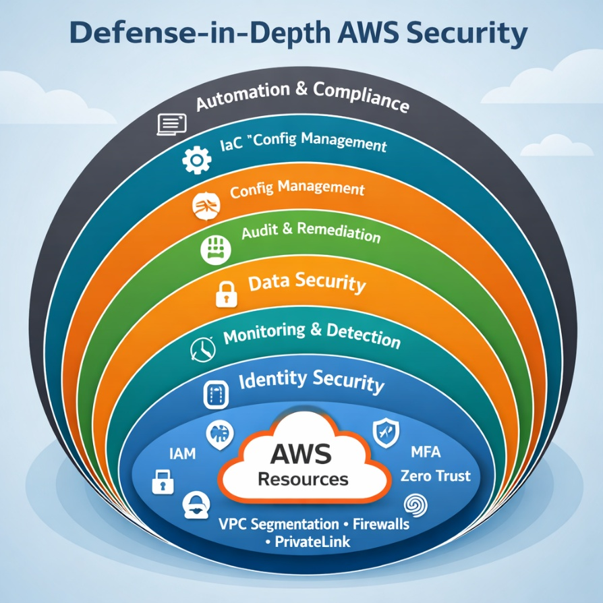
- Conduct regular training to raise awareness of insider risks.
Conclusion
Cloud computing, and specifically AWS environments, represents both an opportunity and a challenge for modern organizations. While AWS provides powerful tools and resilient infrastructure, the majority of cloud breaches stem not from advanced exploits but from misconfigurations, poor governance, and human error.
This project has highlighted the Top 8 vulnerabilities—ranging from misconfigured storage and IAM privilege escalation to insider threats and API exploitation—and provided structured defensive strategies for each. The findings confirm that:
- Security failures are primarily architectural and operational.
- Defense-in-Depth and Zero Trust models are essential to reduce risk.
- Automation and continuous monitoring significantly strengthen resilience against evolving threats.
Ultimately, cloud security is not a static product but a continuous process of governance, monitoring, and improvement. Organizations that embrace automation, enforce strict identity and access controls, and integrate advanced detection systems will be far better positioned to withstand the complex threat landscape of the cloud era.
References
- Cloud Industry Review. 5 Critical AWS Vulnerabilities You Need to Address.
https://cloudindustryreview.com/5-critical-aws-vulnerabilities-you-need-to-address/ (cloudindustryreview.com in Bing)
- RedBear IT. Top 10 AWS Security Risks.
https://www.redbearit.com.au/aws/aws-security-risks-top-10/ (redbearit.com.au in Bing)
- SentinelOne. AWS Security Risks Explained.
https://www.sentinelone.com/cybersecurity-101/cloud-security/aws-security-risks/ (sentinelone.com in Bing)
- Amazon Web Services Documentation. AWS Security Best Practices.
https://docs.aws.amazon.com (docs.aws.amazon.com in Bing)
- NIST. Cloud Computing Security Guidelines.
https://csrc.nist.gov/publications (csrc.nist.gov in Bing)
- Cloud Security Alliance (CSA). Top Threats to Cloud Computing.
https://cloudsecurityalliance.org
- Gartner Research. Managing Shadow IT in the Enterprise.
https://www.gartner.com

Introduction to Cloud Incident Response Plan (AWS)
Cloud environments now underpin most enterprise operations, with 94% of businesses reporting stronger security after migrating to the cloud and 91% finding compliance easier to manage. But stronger doesn’t mean invulnerable. The same scale and flexibility that make the cloud so effective also create risks, such as a single misconfiguration, an exposed API, or stolen credentials, that can be exploited before the first alert even appears on your dashboard.
That’s why cloud incident response can’t be a copy-paste of your old incident response plan. In AWS, Azure, and GCP, incidents move at cloud speed – meaning attackers can pivot across regions, services, and even platforms in minutes. Without real-time coordination between teams and providers, you’re already behind when the first alert hits.
The only way to keep pace is with a response framework designed for cloud realities: rapid detection, coordinated containment, and platform-specific playbooks. In the next sections, we’ll break down where the most common gaps are, what “cloud-speed” containment looks like, and how to make sure your team can act before an incident becomes a breach.
Understanding the Cloud Security Incident Landscape
Cloud environments have expanded the attack surface in ways traditional security teams weren’t built to handle. Threats move quickly, often across services and even cloud providers, which means cloud security incident response has to be faster, more coordinated, and platform-aware. Whether it’s AWS, Azure, or GCP incident response, the core challenge is the same: knowing exactly where and how an attack is unfolding and having a cloud incident response plan that works in minutes, not hours.
Incident Types and Attack Vectors
The threats we see most often in enterprise cloud incident management aren’t necessarily new, but the way they unfold in the cloud makes them harder to detect and contain
- Ransomware in the cloud – Attackers often use compromised credentials or vulnerable public services to encrypt data in object storage (like Amazon S3, Azure Blob, or Google Cloud Storage). Without fast cloud threat detection and response, recovery can be complicated by cross-region replication and backup contamination.
- Data exfiltration – Misconfigured access controls, overly permissive IAM roles, and exposed APIs make it easy for attackers to move large volumes of sensitive data out of cloud storage, often without triggering traditional network-based alerts.
- Insider threats – In multi-cloud setups, privileged insiders can exploit legitimate access across services, making detection reliant on deep identity and activity monitoring.
- Misconfigurations – A leading cause of breaches in incident response in cloud computing, from open storage buckets to improperly secured serverless functions. These mistakes are often introduced during rapid deployment cycles.
- API abuse – APIs are core to cloud workflows, but also a prime target. Poor authentication, lack of rate limiting, and unmonitored endpoints create openings for credential stuffing and data harvesting.
- Container and serverless exploitation – Kubernetes clusters, Azure Container Instances, and AWS Lambda functions can be exploited through insecure images, privilege escalation, or supply chain attacks.
What is AWS Security Incident Response?
AWS Security Incident Response helps you quickly prepare for, respond to, and receive guidance to help recover from security incidents. This includes incidents like account takeovers, data breaches, and ransomware attacks.
AWS Security Incident Response triages threat findings, escalates security events, and manages cases that require your immediate attention. Additionally, you have access to Security Incident Response engineers, who will investigate impacted resources.
Monitoring and investigation
AWS Security Incident Response rapidly reviews security threat alerts from Amazon GuardDuty and third-party integrations with AWS Security Hub CSPM, reducing the number your team needs to analyze. It configures suppression rules based on your environment to reduce threat alerts you need to triage and investigate.
Streamline incident response
Scale and execute incident response within minutes with relevant stakeholders, third-party services, and tools.
Self-service security solutions
AWS Security Incident Response provides APIs to integrate and allow you to build your own customized security solutions.
Dashboard for visibility
Monitor and measure incident response readiness.
Security posture
Access AWS best practices and vetted tools for security assessment and rapid incident response investigation.
Expedited assistance
Connect with Security Incident Response engineers to investigate, contain, and receive guidance on ways to recover from security events.
Preparedness and readiness
Implement streamlined notification by setting up your Incident Response team that triggers alerts to designated individuals or groups, with predefined permission policies.
Concepts and Terminology
The following terms and concepts are important for understanding the AWS Security Incident Response service and how it works.
Scope: AWS Security Incident Response aligns with the National Institute of Standards and Technology (NIST) 800-61 Computer Security Incident Handling Guide, providing a consistent approach to security event management as related to industry best practices.
Analysis: The detailed investigation and examination of a security event to understand its scope, impact, and root cause.
AWS Security Incident Response service portal: A self-service portal for you to initiate and manage security event cases. Ongoing communication and reporting facilitated through the ticketing system, automated notifications, and direct engagement with the service team.
Communication: The ongoing dialog and information sharing between the AWS Security Incident Response team and the customer during the incident response process.
Containment, Eradication, and Recovery: The prevention of additional unauthorized activity (containment), coupled with the removal of unauthorized resources and the original vulnerability (eradication), and recovering resources to get back to business as normal.
Continuous Improvement: AWS Security Incident Response incorporates feedback and lessons learned from prior engagements to enhance its detection capabilities, investigative processes, and remediation actions. AWS Security Incident Response also stays up-to-date with the latest security threats and best practices to address evolving security challenges.
Cybersecurity Event: An action that uses an information system or network to produce an adverse effect on the system, network, or information it contains.
Cybersecurity Incident: A violation or imminent threat of violation of computer security policies, acceptable use policies, or standard security practices.
Security Incident Response engineers: A group of individuals who provide support during active security events. For AWS supported cases, this is the Security Incident Response engineers.
Incident Response Workflow: The defined sequence of steps and activities involved in the end-to-end management of a security event, aligned with the NIST 800-61 standard.
Investigative Tooling: AWS Security Incident Response tools and service-linked roles used to review the operational health of your account and resources.
Lessons Learned: The review and documentation of a security event response to identify areas for improvement and inform future incident response planning.
Monitoring and Investigation: AWS Security Incident Response rapidly reviews security alerts from Amazon GuardDuty, bringing to the forefront the most important alerts your team needs to analyze. It configures suppression rules based on the specifics of your environment to prevent unnecessary alerts.
Preparation: The activities undertaken to get an organization ready to effectively respond to and manage security events, such as developing incident response plans and testing procedures.
Reporting and Communication: The processes used to keep you informed throughout the incident response process, including automated notifications, call bridges, and the delivery of investigation artifacts. AWS Security Incident Response provides a single, centralized dashboard in the AWS Management Console to manage all your AWS Security Incident Response efforts.
Responder Generated Intelligence: indicators of compromise; tactics, techniques, and procedures; and associated patterns observed by AWS investigations.
Security Event Expertise: The specialized knowledge and skills required to effectively respond to and manage security events, particularly in the context of the AWS cloud.
Shared Responsibility Model: The division of security responsibilities between AWS and the customer, where AWS is responsible for security of the cloud, and the customer is responsible for security in the cloud.
Threat Intelligence: Internal and external data feeds containing details of unauthorized activity to help identify and respond to evolving security threats.
Ticketing System: A dedicated case management platform that allows you to onboard and manage security event cases, add attachments, and track the incident response lifecycle.
Triage: The initial assessment and prioritization of a security event to determine the appropriate response and next steps.
Workflow: The defined sequence of steps and activities involved in the end-to-end management of a security event.
Prepare for onboarding
We recommend using a proof-of-concept (POC) approach when implementing AWS Security Incident Response. Before deployment, complete the following preparation steps with your internal teams and AWS account team.
Identify key stakeholders: Map out the incident response decision-makers in your organization. Their involvement in policy updates and process changes is essential for a successful rollout.
Validate finding sources: Confirm that all security finding sources are properly configured and deployed. GuardDuty and Security Hub CSPM are critical inputs for the service's auto-triage technology.
Strategic Cloud IR Framework: From Readiness to Recovery
In incident response in cloud computing, speed and precision are everything. The way AWS, Azure, and GCP are built (with shared responsibility, distributed resources, and constant change) means a traditional on-prem playbook is not enough. You need a lifecycle framework designed for cloud security incident response, one that works across providers but respects the quirks of each at the same time.
This framework is based on NIST SP 800-61, then tailored for cloud incident management at enterprise scale. It’s built to shorten detection time, limit attacker movement, and restore operations without losing sight of compliance or reputational risk.
Phase 1 – Preparation and Governance Alignment
A good response starts long before the first alert. That means clear roles, defined responsibilities across providers, and playbooks tailored to each platform.
- In AWS incident response, that might mean pre-approved GuardDuty findings tied to automated IAM lockdowns.
Phase 2 – Detection and Alert Correlation
In multi-cloud environments, you’re dealing with more telemetry, more noise, and more blind spots. Having a centralised SIEM integration is critical for cloud threat detection and response.
Alerts should be normalised across platforms so the SOC can compare like-for-like events, and contextual enrichment (identity data, threat intel, asset tags) should be used to cut through signal fatigue. False positives waste analyst time; missed alerts cost much more. The goal is a detection pipeline that prioritises what matters most to containment.
Phase 3 – Containment and Eradication at Cloud Speed
Containment in the cloud has to be surgical. Kill the wrong process or shut down the wrong workload and you cause more disruption than the attacker. The priority is limiting lateral movement while preserving evidence for forensics.
Examples:
- In AWS, isolating an EC2 instance or restricting IAM roles in seconds using automated scripts.
- In Azure, quarantining a compromised VM while allowing unaffected workloads to run.
- In GCP, snapshotting a Kubernetes node and revoking service account keys before an attacker pivots.
Eradication focuses on removing footholds – deleting malicious Lambda functions, rotating keys, patching exploited APIs – without delaying business-critical services.
Phase 4 – Recovery and Business Restoration
Recovery isn’t just “bringing it back online.” It’s restoring operations with confidence that the environment is clean, vulnerabilities are closed, and the same attack can’t be repeated.
Best practices here include:
- Restoring workloads from verified, uncompromised backups.
- Using forensic validation to confirm that no persistence mechanisms remain.
- Coordinating leadership communications to customers, regulators, and partners to control reputational impact.
- Effective recovery is both a technical and a trust exercise – a core part of cloud security response.
Phase 5 – Post-Incident Learning and Risk Reduction
An incident only has lasting value if it improves your future resilience. Every cloud incident should end with a structured review that feeds directly into security strategy, architecture, and compliance obligations.
Post-incident steps should include:
- Updating cloud incident response best practices and playbooks based on lessons learned.
- Feeding new IoCs and detection logic into SIEM/SOAR tooling.
- Documenting actions for regulatory reports and audits.
- Running targeted training for teams where human error contributed to the event.
Platform-Specific Best Practices for AWS
AWS gives you a strong native toolkit for detection, investigation, and response — but only if those tools are deployed with intent and wired into your wider incident process.
- CloudTrail as the source of truth. Every investigation starts with knowing exactly what happened and when. Make sure CloudTrail is logging across all regions, capturing both management and data events, and storing logs in a versioned, immutable S3 bucket. Without this, you’re flying blind.
- GuardDuty with context. GuardDuty can surface real threats, but raw findings aren’t enough. Enrich them with identity data, asset context, and threat intel so your team knows which alerts demand immediate action.
- Incident Manager for fast, repeatable actions. Pre-configure Incident Manager to trigger on high-severity events. This can automate quarantining compromised EC2 instances, rotating keys, or blocking risky S3 activity without having to wait for manual approval.
- IAM forensics. Most cloud breaches hinge on identity misuse. Cross-reference CloudTrail events with IAM access patterns to reconstruct exactly who did what, from which location, and with which permissions.
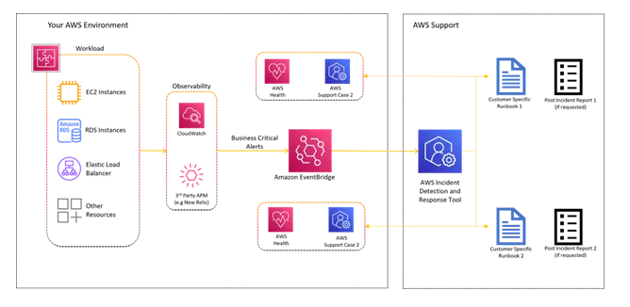
- Test under real conditions. Run controlled simulations, from GuardDuty-triggered alerts to IAM credential compromises, to prove your run books work as expected. Simulations expose where automation fails, where escalation slows, and where people need more training.
Executive Decision-Making During Cloud IR
When an incident hits, CISOs and boards don’t need every technical detail; they need a clear picture to make time-critical decisions. That means:
- Escalation paths – Who gets notified, in what order, and at what threshold. This avoids bottlenecks where critical actions stall waiting for approval.
- Containment windows – How much time you have before the attacker can cause irreversible damage, and what trade-offs come with faster action (e.g., service impact vs. data loss prevention).
- Legal thresholds – The point at which an incident triggers regulatory reporting, contractual obligations, or public disclosure. Waiting too long can turn a security issue into a compliance crisis.
Quantifying Cloud IR Readiness and Risk Reduction
You can’t manage what you can’t measure. Tracking the right metrics gives leadership a clear view of readiness and the ROI on response investments. Common measures include:
- MTTR (Mean Time to Respond/Recover) – How quickly you detect, contain, and restore normal operations.
- Dwell time – How long an attacker is active before detection. Shortening this is one of the most effective ways to reduce impact.
- Cost per incident – A blend of operational disruption, remediation spend, legal costs, and any regulatory penalties.
- Post-incident hardening rate – How many lessons learned are actually implemented in the following quarter.

Disaster Recovery of Workloads on AWS:
Recovery in the Cloud
Your workload must perform its intended function correctly and consistently. To achieve this, you must architect for resiliency. Resiliency is the ability of a workload to recover from infrastructure, service, or application disruptions, dynamically acquire computing resources to meet demand, and mitigate disruptions, such as misconfigurations or transient network issues.
Disaster recovery (DR) is an important part of your resiliency strategy and concerns how your workload responds when a disaster strikes (a disaster is an event that causes a serious negative impact on your business). This response must be based on your organization's business objectives which specify your workload's strategy for avoiding loss of data, known as the Recovery Point Objective (RPO), and reducing downtime where your workload is not available for use, known as the Recovery Time Objective (RTO). You must therefore implement resilience in the design of your workloads in the cloud to meet your recovery objectives (RPO and RTO) for a given one-time disaster event. This approach helps your organization to maintain business continuity as part of Business Continuity Planning (BCP).
Disaster recovery and availability
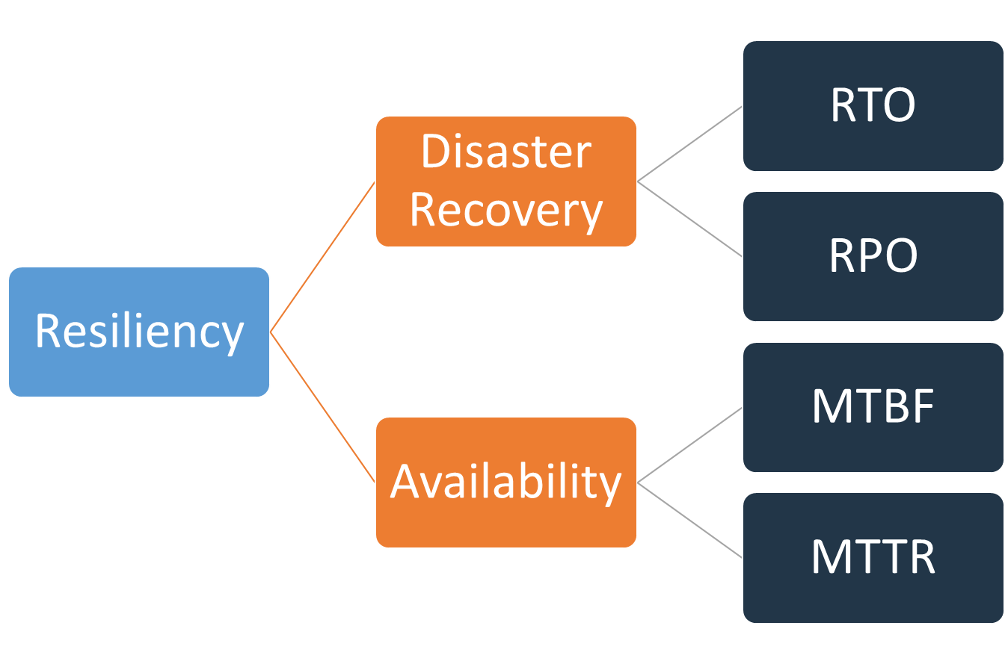
Disaster recovery can be compared to availability, which is another important component of your resiliency strategy. Whereas disaster recovery measures objectives for one-time events, availability objectives measure mean values over a period of time.
Disaster recovery focuses on disaster events, whereas availability focuses on more common disruptions of smaller scale such as component failures, network issues, software bugs, and load spikes. The objective of disaster recovery is business continuity, whereas availability concerns maximizing the time that a workload is available to perform its intended business functionality. Both should be part of your resiliency strategy.
Shared Responsibility Model for Resiliency
Resiliency is a shared responsibility between AWS and you, the customer. It is important that you understand how disaster recovery and availability, as part of resiliency, operate under this shared model.
AWS is responsible for resiliency of the infrastructure that runs all of the services offered in the AWS Cloud. This infrastructure comprises the hardware, software, networking, and facilities that run AWS Cloud services. AWS uses commercially reasonable efforts to make these AWS Cloud services available, ensuring service availability meets or exceeds AWS Service Level Agreements (SLAs).
Customer responsibility “Resiliency in the Cloud”
Your responsibility will be determined by the AWS Cloud services that you select. This determines the amount of configuration work you must perform as part of your resiliency responsibilities. For example, a service such as Amazon Elastic Compute Cloud (Amazon EC2) requires the customer to perform all of the necessary resiliency configuration and management tasks. Customers that deploy Amazon EC2 instances are responsible for deploying EC2 instances across multiple locations (such as AWS Availability Zones), implementing self-healing using services like Amazon EC2 Auto Scaling, as well as using resilient workload architecture best practices for applications installed on the instances. For managed services, such as Amazon S3 and Amazon DynamoDB, AWS operates the infrastructure layer, the operating system, and platforms, and customers access the endpoints to store and retrieve data. You are responsible for managing resiliency of your data including backup, versioning, and replication strategies.
Deploying your workload across multiple Availability Zones in an AWS Region is part of a high availability strategy designed to protect workloads by isolating issues to one Availability Zone, and uses the redundancy of the other Availability Zones to continue serving requests. A Multi-AZ architecture is also part of a DR strategy designed to make workloads better isolated and protected from issues such as power outages, lightning strikes, tornadoes, earthquakes, and more. DR strategies may also make use of multiple AWS Regions. For example in an active/passive configuration, service for the workload will fail over from its active region to its DR region if the active Region can no longer serve requests.
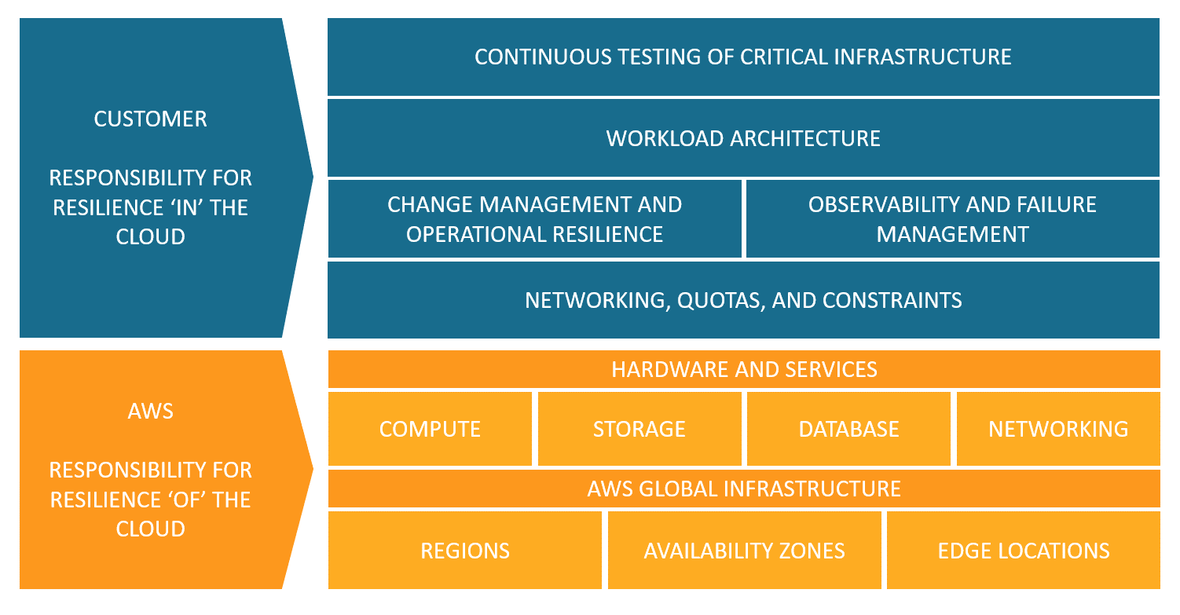

When planning for disaster recovery, evaluate your plan for these three main categories of disaster:
- Natural disasters, such as earthquakes or floods
- Technical failures, such as power failure or network connectivity
- Human actions, such as inadvertent misconfiguration or unauthorized/outside party access or modification
Each of these potential disasters will also have a geographical impact that can be local, regional, country-wide, continental, or global. Both the nature of the disaster and the geographical impact are important when considering your disaster recovery strategy. For example, you can mitigate a local flooding issue causing a data center outage by employing a Multi-AZ strategy, since it would not affect more than one Availability Zone. However, an attack on production data would require you to invoke a disaster recovery strategy that fails over to backup data in another AWS Region.
High availability is not disaster recovery
Both availability and disaster recovery rely on some of the same best practices, such as monitoring for failures, deploying to multiple locations, and automatic failover. However, Availability focuses on components of the workload, whereas disaster recovery focuses on discrete copies of the entire workload. Disaster recovery has different objectives from Availability, measuring time to recovery after the larger scale events that qualify as disasters. You should first ensure your workload meets your availability objectives, as a highly available architecture will enable you to meet customers’ needs in the event of availability impacting events. Your disaster recovery strategy requires different approaches than those for availability, focusing on deploying discrete systems to multiple locations, so that you can fail over the entire workload if necessary.
You must consider the availability of your workload in disaster recovery planning, as it will influence the approach you take. A workload that runs on a single Amazon EC2 instance in one Availability Zone does not have high availability. If a local flooding issue affects that Availability Zone, this scenario requires failover to another AZ to meet DR objectives. Compare this scenario to a highly available workload deployed multi-site active/active, where the workload is deployed across multiple active Regions and all Regions are serving production traffic. In this case, even in the unlikely event a massive disaster makes a Region unusable, the DR strategy is accomplished by routing all traffic to the remaining Regions.
How you approach data is also different between availability and disaster recovery. Consider a storage solution that continuously replicates to another site to achieve high availability (such as a multi-site, active/active workload). If a file or files are deleted or corrupted on the primary storage device, those destructive changes can be replicated to the secondary storage device. In this scenario, despite high availability, the ability to fail over in case of data deletion or corruption will be compromised. Instead, a point-in-time backup is also required as part of a DR strategy.

Business Continuity Plan (BCP)
Your disaster recovery plan should be a subset of your organization’s business continuity plan (BCP), it should not be a standalone document. There is no point in maintaining aggressive disaster recovery targets for restoring a workload if that workload’s business objectives cannot be achieved because of the disaster’s impact on elements of your business other than your workload. For example an earthquake might prevent you from transporting products purchased on your eCommerce application – even if effective DR keeps your workload functioning, your BCP needs to accommodate transportation needs. Your DR strategy should be based on business requirements, priorities, and context.
- Business impact analysis and risk assessment
A business impact analysis should quantify the business impact of a disruption to your workloads. It should identify the impact on internal and external customers of not being able to use your workloads and the effect that has on your business. The analysis should help to determine how quickly the workload needs to be made available and how much data loss can be tolerated. However, it is important to note that recovery objectives should not be made in isolation; the probability of disruption and cost of recovery are key factors that help to inform the business value of providing disaster recovery for a workload.
Business impact may be time dependent. You may want to consider factoring this in to your disaster recovery planning. For example, disruption to your payroll system is likely to have a very high impact to the business just before everyone gets paid, but it may have a low impact just after everyone has already been paid.
A risk assessment of the type of disaster and geographical impact along with an overview of the technical implementation of your workload will determine the probability of disruption occurring for each type of disaster.
For highly critical workloads, you might consider deploying infrastructure across multiple Regions with data replication and continuous backups in place to minimize business impact. For less critical workloads, a valid strategy may be not to have any disaster recovery in place at all. And for some disaster scenarios, it is also valid not to have any disaster recovery strategy in place as an informed decision based on a low probability of the disaster occurring. Remember that Availability Zones within an AWS Region are already designed with meaningful distance between them, and careful planning of location, such that most common disasters should only impact one zone and not the others. Therefore, a multi-AZ architecture within an AWS Region may already meet much of your risk mitigation needs.
The cost of the disaster recovery options should be evaluated to ensure that the disaster recovery strategy provides the correct level of business value considering the business impact and risk.
With all of this information, you can document the threat, risk, impact and cost of different disaster scenarios and the associated recovery options. This information should be used to determine your recovery objectives for each of your workloads.

- Recovery objectives (RTO and RPO)
When creating a Disaster Recovery (DR) strategy, organizations most commonly plan for the Recovery Time Objective (RTO) and Recovery Point Objective (RPO).
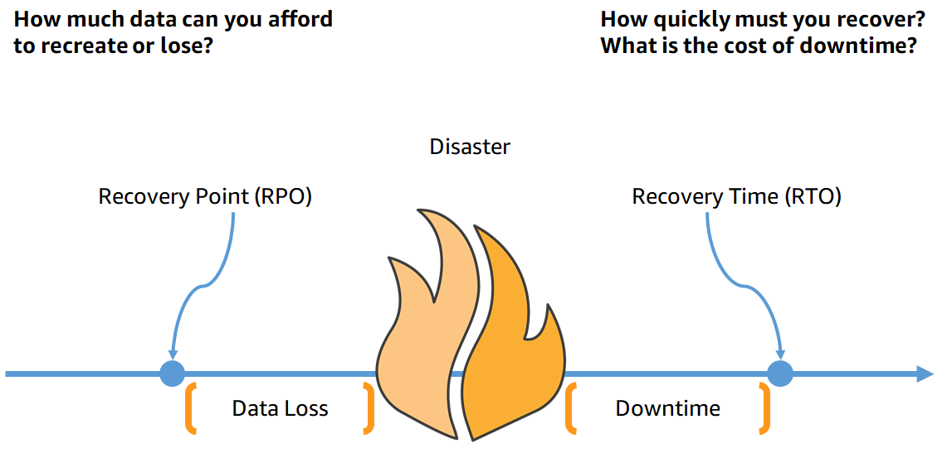
Recovery Time Objective (RTO) is the maximum acceptable delay between the interruption of service and restoration of service. This objective determines what is considered an acceptable time window when service is unavailable and is defined by the organization.
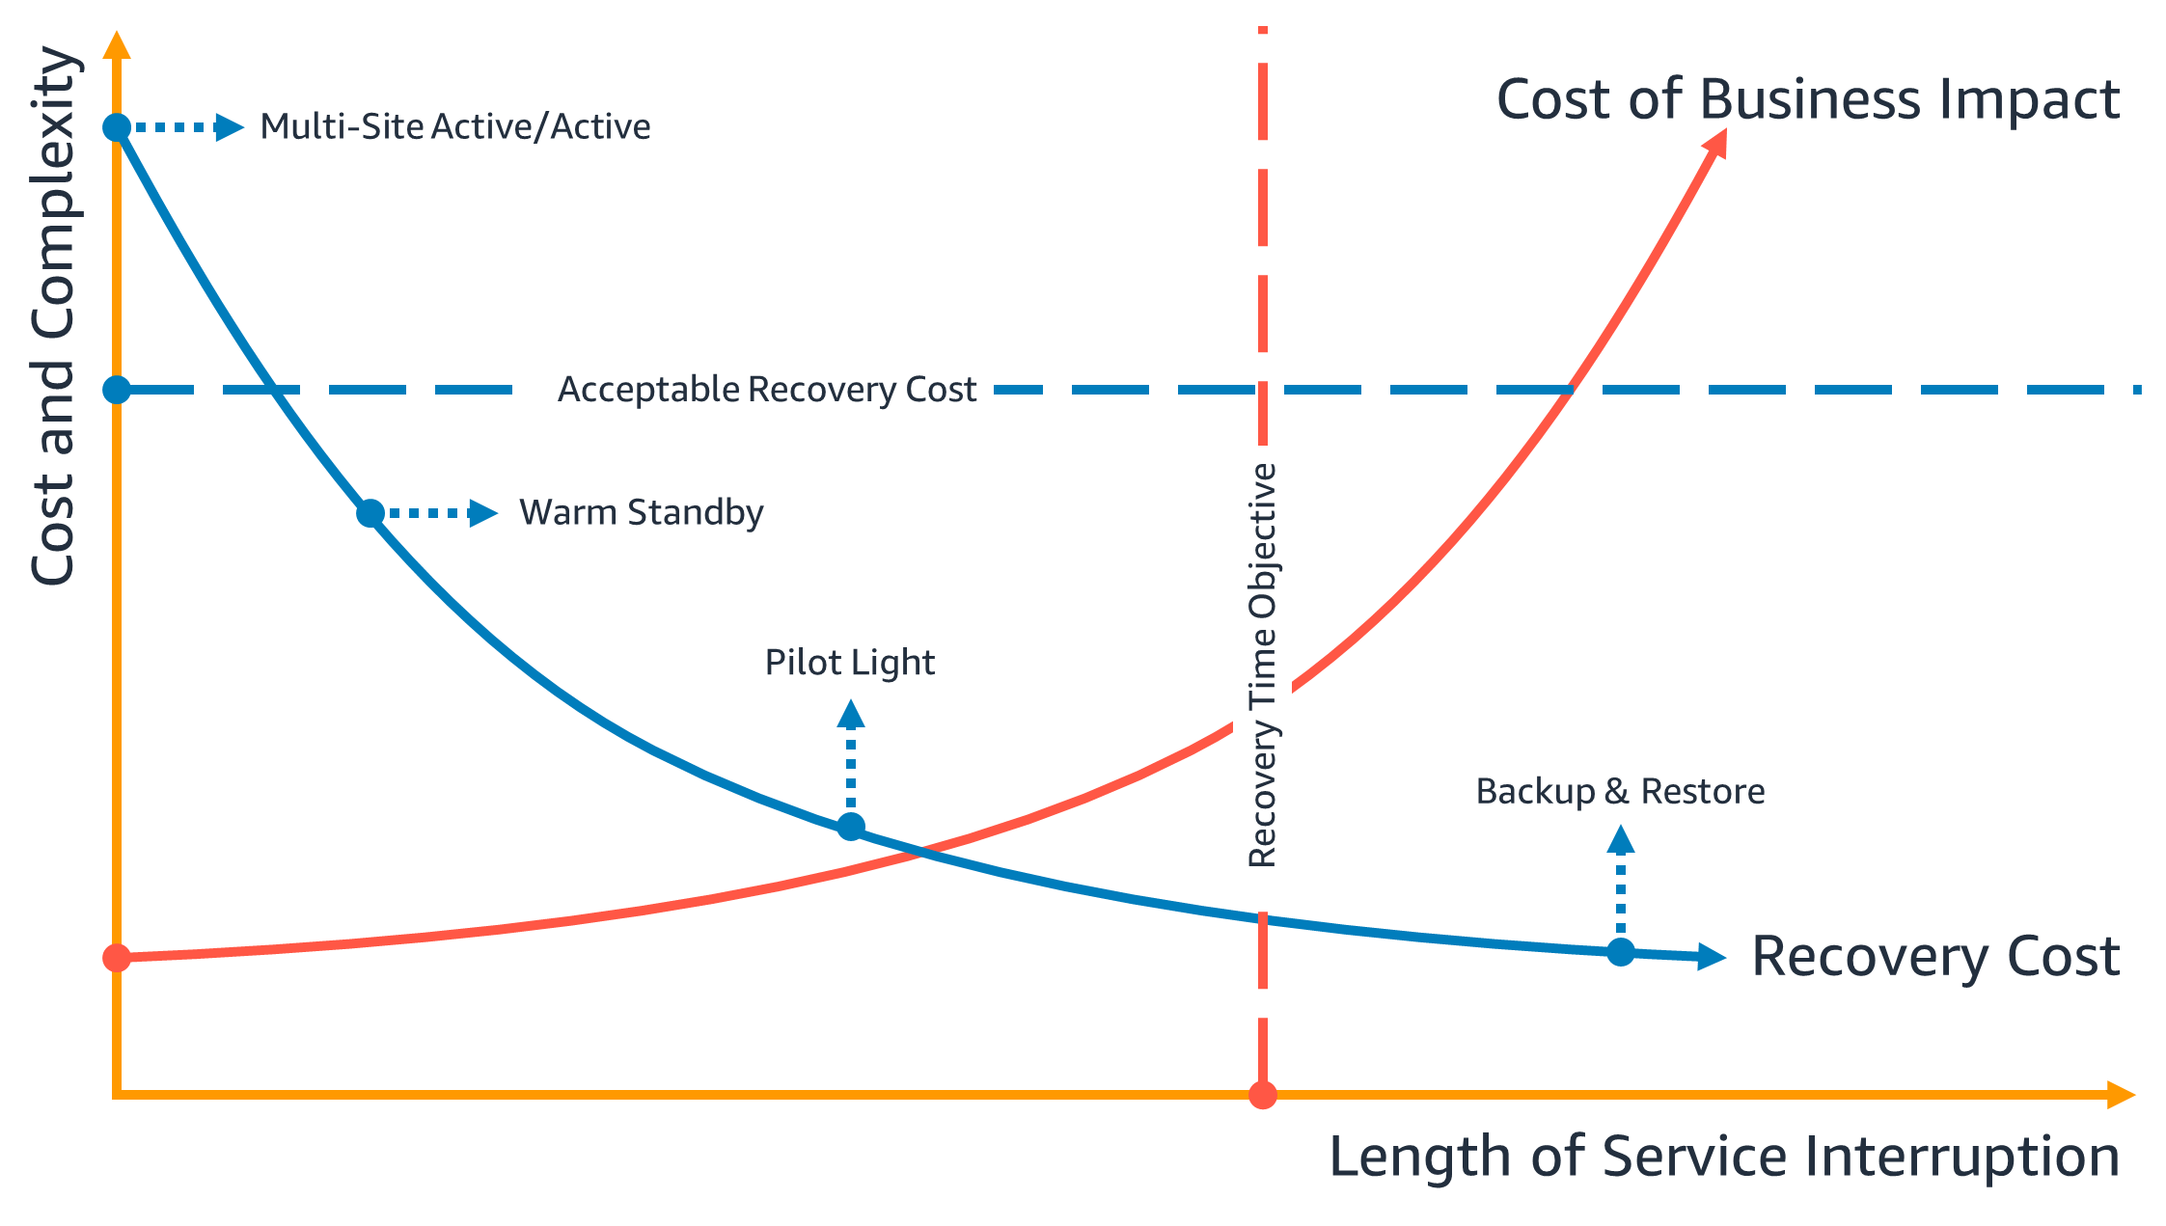
In the following diagram, the business has determined their maximum permissible RTO as well as the limit of what they can spend on their service restoration strategy. Given the business’ objectives, the DR strategies Pilot Light or Warm Standby will satisfy both the RTO and the cost criteria.

Recovery Point Objective (RPO) is the maximum acceptable amount of time since the last data recovery point. This objective determines what is considered an acceptable loss of data between the last recovery point and the interruption of service and is defined by the organization.
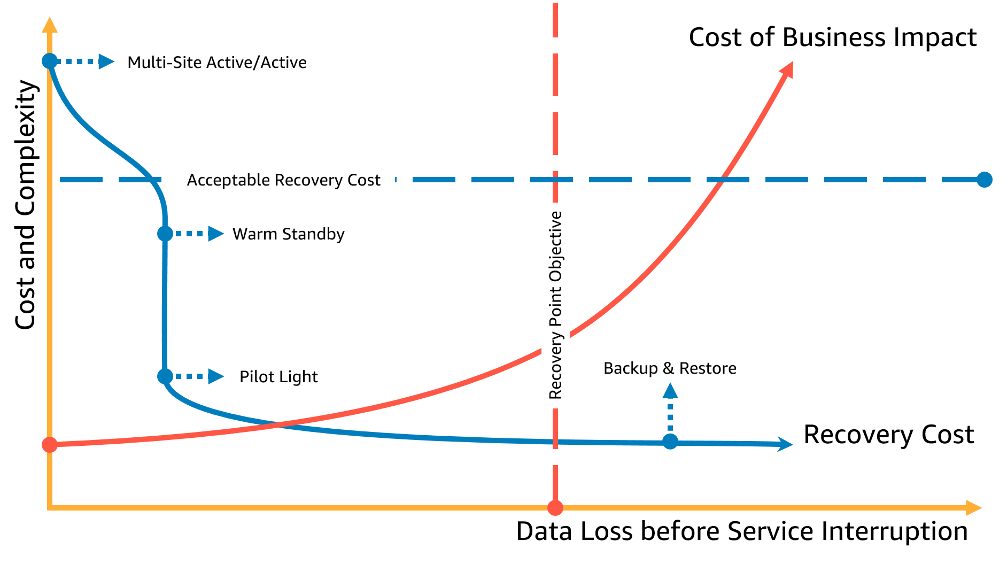
In the following diagram, the business has determined their maximum permissible RPO as well as the limit of what they can spend on their data recovery strategy. Of the four DR strategies, either Pilot Light or Warm Standby DR strategy meet both criteria for RPO and cost.

Disaster recovery is different in the cloud
Disaster recovery strategies evolve with technical innovation. A disaster recovery plan on-premises may involve physically transporting tapes or replicating data to another site. Your organization needs to re-evaluate the business impact, risk, and cost of its previous disaster recovery strategies in order to fulfil its DR objectives on AWS. Disaster recovery in the AWS Cloud includes the following advantages over traditional environments:
- Recover quickly from a disaster with reduced complexity
- Simple and repeatable testing allow you to test more easily and more frequently
- Lower management overhead decreases operational burden
- Opportunities to automate decrease chances of error and improve recovery time
AWS allows you to trade the fixed capital expense of a physical backup data center for the variable operating expense of a right sized environment in the cloud, which can significantly reduce cost.
For a lot of organizations, on-premises disaster recovery was based around the risk of disruption to a workload or workloads in a data center and the recovery of backed up or replicated data to a secondary data center. When organizations deploy workloads on AWS, they can implement a well-architected workload and rely on the design of the AWS Global Cloud Infrastructure to help mitigate the effect of such disruptions.
If your workloads are on AWS, you don’t need to worry about data center connectivity (with the exception of your ability to access it), power, air conditioning, fire suppression and hardware. All of this is managed for you and you have access to multiple fault-isolated Availability Zones (each made up of one or more discrete data centers).
- Single AWS Region
For a disaster event based on disruption or loss of one physical data center, implementing a highly available workload in multiple Availability Zones within a single AWS Region helps mitigate against natural and technical disasters. Continuous backup of data within this single Region can reduce the risk to human threats, such as an error or unauthorized activity that could result in data loss. Each AWS Region is comprised of multiple Availability Zones, each isolated from faults in the other zones. Each Availability Zone in turn consists of one or more discrete physical data centers. To better isolate impactful issues and achieve high availability, you can partition workloads across multiple zones in the same Region. Availability Zones are designed for physical redundancy and provide resilience, allowing for uninterrupted performance, even in the event of power outages, Internet downtime, floods, and other natural disasters.
By deploying across multiple Availability Zones in a single AWS Region, your workload is better protected against failure of a single (or even multiple) data centers. For extra assurance with your single-Region deployment, you can back up data and configuration (including infrastructure definition) to another Region. This strategy reduces the scope of your disaster recovery plan to only include data backup and restoration. Leveraging multi-region resiliency by backing up to another AWS Region is simple and inexpensive relative to the other multi-Region options described in the following section. For example, backing up to Amazon Simple Storage Service (Amazon S3) gives you access to immediate retrieval of your data. However if your DR strategy for portions of your data has more relaxed requirements for retrieval times (from minutes to hours), then using Amazon Glacier or Amazon Glacier Deep Archive will significantly reduce costs of your backup and recovery strategy.
Some workloads may have regulatory data residency requirements. If this applies to your workload in a locality that currently has only one AWS Region, then in addition to designing multi-AZ workloads for high availability as discussed above, you can also use the AZs within that Region as discrete locations, which can be helpful for addressing data residency requirements applicable to your workload within that Region. The DR strategies described in the following sections use multiple AWS Regions, but can also be implemented using Availability Zones instead of Regions.
- Multiple AWS Regions
For a disaster event that includes the risk of losing multiple data centers a significant distance away from each other, you should consider disaster recovery options to mitigate against natural and technical disasters that affect an entire Region within AWS. All of the options described in the following sections can be implemented as multi-Region architectures to protect against such disasters.

Disaster recovery options in the cloud
Disaster recovery strategies available to you within AWS can be broadly categorized into four approaches, ranging from the low cost and low complexity of making backups to more complex strategies using multiple active Regions. Active/passive strategies use an active site (such as an AWS Region) to host the workload and serve traffic. The passive site (such as a different AWS Region) is used for recovery. The passive site does not actively serve traffic until a failover event is triggered.
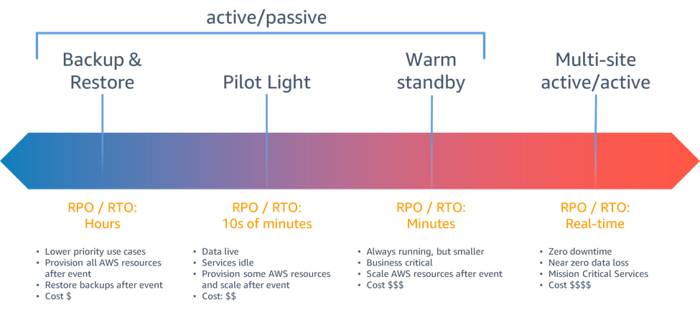
For a disaster event based on disruption or loss of one physical data center for a well-architected, highly available workload, you may only require a backup and restore approach to disaster recovery. If your definition of a disaster goes beyond the disruption or loss of a physical data center to that of a Region or if you are subject to regulatory requirements that require it, then you should consider Pilot Light, Warm Standby, or Multi-Site Active/Active.
When choosing your strategy, and the AWS resources to implement it, keep in mind that within AWS, we commonly divide services into the data plane and the control plane. The data plane is responsible for delivering real-time service while control planes are used to configure the environment. For maximum resiliency, you should use only data plane operations as part of your failover operation. This is because the data planes typically have higher availability design goals than the control planes.
- Backup and restore
Backup and restore is a suitable approach for mitigating against data loss or corruption. This approach can also be used to mitigate against a regional disaster by replicating data to other AWS Regions, or to mitigate lack of redundancy for workloads deployed to a single Availability Zone. In addition to data, you must redeploy the infrastructure, configuration, and application code in the recovery Region. To enable infrastructure to be redeployed quickly without errors, you should always deploy using infrastructure as code (IaC) using services such as AWS Cloud Formation or the AWS Cloud Development Kit (AWS CDK). Without IaC, it may be complex to restore workloads in the recovery Region, which will lead to increased recovery times and possibly exceed your RTO. In addition to user data, be sure to also back up code and configuration, including Amazon Machine Images (AMIs) you use to create Amazon EC2 instances. You can use AWS Code Pipeline to automate redeployment of application code and configuration.
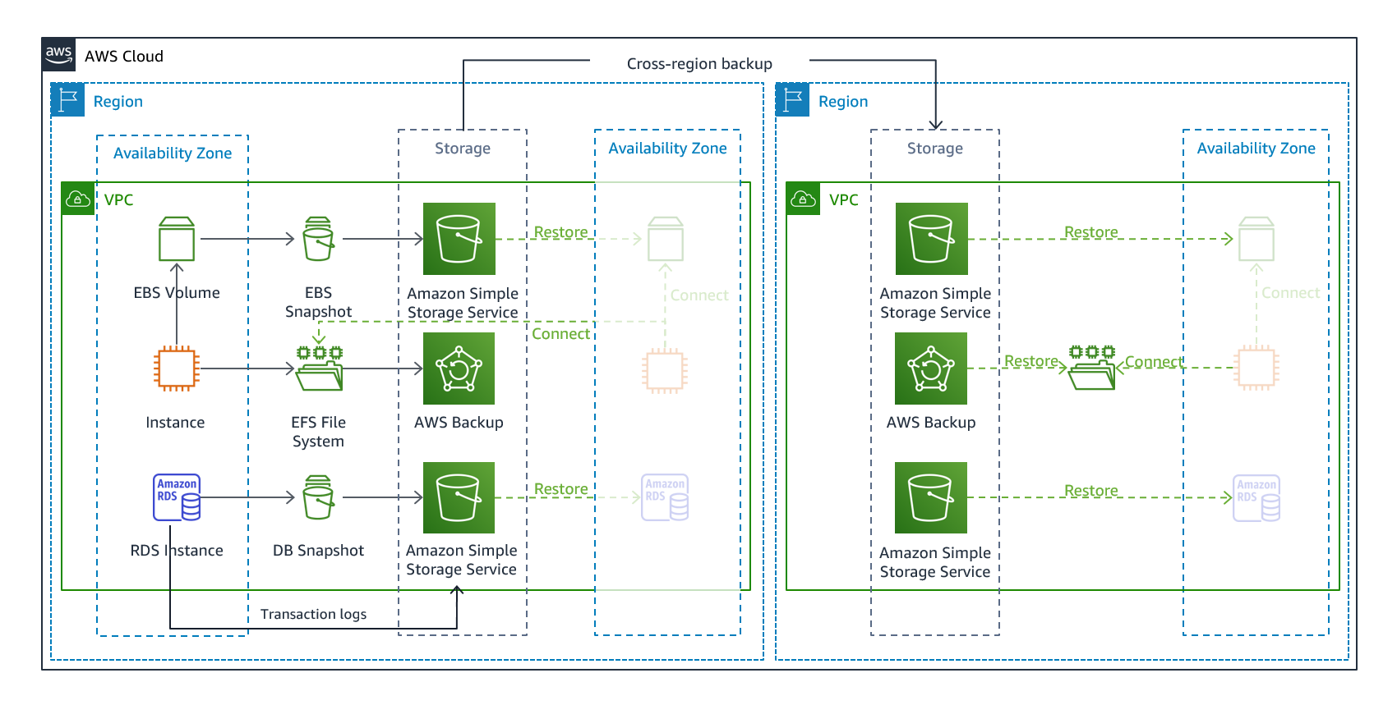
- AWS services
Your workload data will require a backup strategy that runs periodically or is continuous. How often you run your backup will determine your achievable recovery point (which should align to meet your RPO). The backup should also offer a way to restore it to the point in time in which it was taken. Backup with point-in-time recovery is available through the following services and resources:
- Amazon Elastic Block Store (Amazon EBS) snapshot
- Amazon DynamoDB backup
- Amazon RDS snapshot
- Amazon Aurora DB snapshot
- Amazon EFS backup (when using AWS Backup)
- Amazon Redshift snapshot
- Amazon Neptune snapshot
- Amazon DocumentDB
- Amazon FSx for Windows File Server, Amazon FSx for Lustre, Amazon FSx for NetApp ONTAP, and Amazon FSx for OpenZFS
For Amazon Simple Storage Service (Amazon S3), you can use Amazon S3 Cross-Region Replication (CRR) to asynchronously copy objects to an S3 bucket in the DR region continuously, while providing versioning for the stored objects so that you can choose your restoration point. Continuous replication of data has the advantage of being the shortest time (near zero) to back up your data, but may not protect against disaster events such as data corruption or malicious attack (such as unauthorized data deletion) as well as point-in-time backups.
AWS Backup provides a centralized location to configure, schedule, and monitor AWS backup capabilities for the following services and resources:
- Amazon Elastic Block Store (Amazon EBS) volumes
- Amazon EC2 instances
- Amazon Relational Database Service (Amazon RDS) databases (including Amazon Aurora databases)
- Amazon DynamoDB tables
- Amazon Elastic File System (Amazon EFS) file systems
- AWS Storage Gateway volumes
- Amazon FSx for Windows File Server, Amazon FSx for Lustre, Amazon FSx for NetApp ONTAP, and Amazon FSx for OpenZFS
AWS Backup supports copying backups across Regions, such as to a disaster recovery Region.
As an additional disaster recovery strategy for your Amazon S3 data, enable S3 object versioning. Object versioning protects your data in S3 from the consequences of deletion or modification actions by retaining the original version before the action. Object versioning can be a useful mitigation for human-error type disasters. If you are using S3 replication to back up data to your DR region, then, by default, when an object is deleted in the source bucket, Amazon S3 adds a delete marker in the source bucket only. This approach protects data in the DR Region from malicious deletions in the source Region.
In addition to data, you must also back up the configuration and infrastructure necessary to redeploy your workload and meet your Recovery Time Objective (RTO). AWS CloudFormation provides Infrastructure as Code (IaC), and enables you to define all of the AWS resources in your workload so you can reliably deploy and redeploy to multiple AWS accounts and AWS Regions. You can back up Amazon EC2 instances used by your workload as Amazon Machine Images (AMIs). The AMI is created from snapshots of your instance's root volume and any other EBS volumes attached to your instance. You can use this AMI to launch a restored version of the EC2 instance. An AMI can be copied within or across Regions. Or, you can use AWS Backup to copy backups across accounts and to other AWS Regions. The cross-account backup capability helps protect from disaster events that include insider threats or account compromise. AWS Backup also adds additional capabilities for EC2 backup—in addition to the instance’s individual EBS volumes, AWS Backup also stores and tracks the following metadata: instance type, configured virtual private cloud (VPC), security group, IAM role, monitoring configuration, and tags. However, this additional metadata is only used when restoring the EC2 backup to the same AWS Region.
Any data stored in the disaster recovery Region as backups must be restored at time of failover. AWS Backup offers restore capability, but does not currently enable scheduled or automatic restoration. You can implement automatic restore to the DR region using the AWS SDK to call APIs for AWS Backup. You can set this up as a regularly recurring job or trigger restoration whenever a backup is completed. The following figure shows an example of automatic restoration using Amazon Simple Notification Service (Amazon SNS) and AWS Lambda. Implementing a scheduled periodic data restore is a good idea as data restore from backup is a control plane operation. If this operation was not available during a disaster, you would still have operable data stores created from a recent backup.
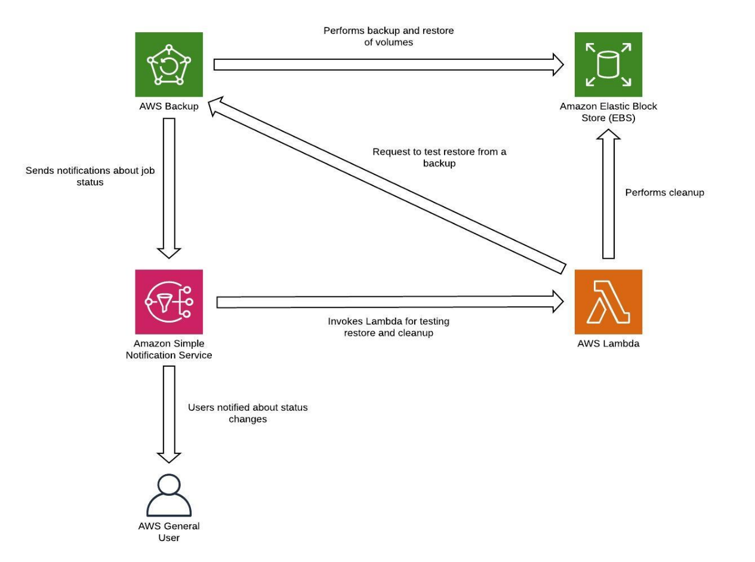

- Pilot light
With the pilot light approach, you replicate your data from one Region to another and provision a copy of your core workload infrastructure. Resources required to support data replication and backup, such as databases and object storage, are always on. Other elements, such as application servers, are loaded with application code and configurations, but are "switched off" and are only used during testing or when disaster recovery failover is invoked. In the cloud, you have the flexibility to deprovision resources when you do not need them, and provision them when you do. A best practice for “switched off” is to not deploy the resource, and then create the configuration and capabilities to deploy it (“switch on”) when needed. Unlike the backup and restore approach, your core infrastructure is always available and you always have the option to quickly provision a full scale production environment by switching on and scaling out your application servers.
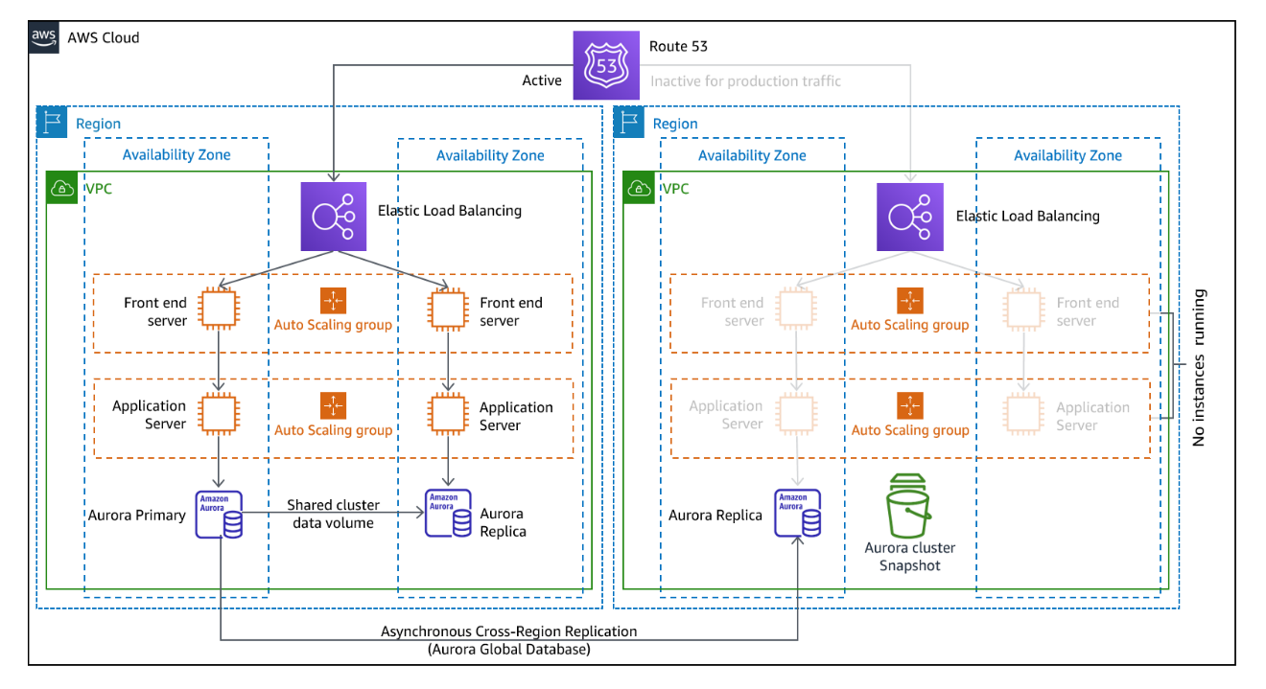
A pilot light approach minimizes the ongoing cost of disaster recovery by minimizing the active resources, and simplifies recovery at the time of a disaster because the core infrastructure requirements are all in place. This recovery option requires you to change your deployment approach. You need to make core infrastructure changes to each Region and deploy workload (configuration, code) changes simultaneously to each Region. This step can be simplified by automating your deployments and using infrastructure as code (IaC) to deploy infrastructure across multiple accounts and Regions (full infrastructure deployment to the primary Region and scaled down/switched-off infrastructure deployment to DR regions). It is recommended you use a different account per Region to provide the highest level of resource and security isolation (in the case compromised credentials are part of your disaster recovery plans as well).

With this approach, you must also mitigate against a data disaster. Continuous data replication protects you against some types of disaster, but it may not protect you against data corruption or destruction unless your strategy also includes versioning of stored data or options for point-in-time recovery. You can back up the replicated data in the disaster Region to create point-in-time backups in that same Region.
- AWS services
In addition to using the AWS services covered in the Backup and Restore section to create point-in-time backups, also consider the following services for your pilot light strategy.
For pilot light, continuous data replication to live databases and data stores in the DR region is the best approach for low RPO (when used in addition to the point-in-time backups discussed previously). AWS provides continuous, cross-region, asynchronous data replication for data using the following services and resources:
- Amazon Simple Storage Service (Amazon S3) Replication
- Amazon RDS read replicas
- Amazon Aurora global databases
- Amazon DynamoDB global tables
- Amazon DocumentDB global clusters
- Global Datastore for Amazon ElastiCache (Redis OSS)
With continuous replication, versions of your data are available almost immediately in your DR Region. Actual replication times can be monitored using service features like S3 Replication Time Control (S3 RTC) for S3 objects and management features of Amazon Aurora global databases.
When failing over to run your read/write workload from the disaster recovery Region, you must promote an RDS read replica to become the primary instance. For DB instances other than Aurora, the process takes a few minutes to complete and rebooting is part of the process. For Cross-Region Replication (CRR) and failover with RDS, using Amazon Aurora global database provides several advantages. Global database uses dedicated infrastructure that leaves your databases entirely available to serve your application, and can replicate to the secondary Region with typical latency of under a second (and within an AWS Region is much less than 100 milliseconds). With Amazon Aurora global database, if your primary Region suffers a performance degradation or outage, you can promote one of the secondary regions to take read/write responsibilities in less than one minute even in the event of a complete regional outage. You can also configure Aurora to monitor the RPO lag time of all secondary clusters to make sure that at least one secondary cluster stays within your target RPO window.
A scaled down version of your core workload infrastructure with fewer or smaller resources must be deployed in your DR Region. Using AWS CloudFormation, you can define your infrastructure and deploy it consistently across AWS accounts and across AWS Regions. AWS CloudFormation uses predefined pseudo parameters to identify the AWS account and AWS Region in which it is deployed. Therefore, you can implement condition logic in your CloudFormation templates to deploy only the scaled-down version of your infrastructure in the DR Region. For EC2 instance deployments, an Amazon Machine Image (AMI) supplies information such as hardware configuration and installed software. You can implement an Image Builder pipeline that creates the AMIs you need and copy these to both your primary and backup Regions. This helps to ensure that these golden AMIs have everything you need to re-deploy or scale-out your workload in a new region, in case of a disaster event. Amazon EC2 instances are deployed in a scaled-down configuration (less instances than in your primary Region).
For an active/passive configuration such as pilot light, all traffic initially goes to the primary Region and switches to the disaster recovery Region if the primary Region is no longer available. This failover operation can be initiated either automatically or manually. Automatically initiated failover based on health checks or alarms should be used with caution. Even using the best practices discussed here, recovery time and recovery point will be greater than zero, incurring some loss of availability and data. If you fail over when you don’t need to (false alarm), then you incur those losses. Manually initiated failover is therefore often used. In this case, you should still automate the steps for failover, so that the manual initiation is like the push of a button.
There are several traffic management options to consider when using AWS services.
One option is to use Amazon Route 53. Using Amazon Route 53, you can associate multiple IP endpoints in one or more AWS Regions with a Route 53 domain name. Then, you can route traffic to the appropriate endpoint under that domain name. On failover you need to switch traffic to the recovery endpoint, and away from the primary endpoint. Amazon Route 53 health checks monitor these endpoints. Using these health checks, you can configure automatically initiated DNS failover to ensure traffic is sent only to healthy endpoints, which is a highly reliable operation done on the data plane. To implement this using manually initiated failover you can use Amazon Application Recovery Controller (ARC). With ARC, you can create Route 53 health checks that do not actually check health, but instead act as on/off switches that you have full control over. Using the AWS CLI or AWS SDK, you can script failover using this highly available, data plane API. Your script toggles these switches (the Route 53 health checks) telling Route 53 to send traffic to the recovery Region instead of the primary Region. Another option for manually initiated failover that some have used is to use a weighted routing policy and change the weights of the primary and recovery Regions so that all traffic goes to the recovery Region. However, be aware this is a control plane operation and therefore not as resilient as the data plane approach using Amazon Application Recovery Controller (ARC).
Another option is to use AWS Global Accelerator. Using AnyCast IP, you can associate multiple endpoints in one or more AWS Regions with the same static public IP address or addresses. AWS Global Accelerator then routes traffic to the appropriate endpoint associated with that address. Global Accelerator health checks monitor endpoints. Using these health checks, AWS Global Accelerator checks the health of your applications and routes user traffic automatically to the healthy application endpoint. For manually initiated failover, you can adjust which endpoint receives traffic using traffic dials, but note this is a control plane operation. Global Accelerator offers lower latencies to the application endpoint since it makes use of the extensive AWS edge network to put traffic on the AWS network backbone as soon as possible. Global Accelerator also avoids caching issues that can occur with DNS systems (like Route 53).
Amazon CloudFront offers origin failover, where if a given request to the primary endpoint fails, CloudFront routes the request to the secondary endpoint. Unlike the failover operations described previously, all subsequent requests still go to the primary endpoint, and failover is done per each request.
AWS Elastic Disaster Recovery
AWS Elastic Disaster Recovery (DRS) continuously replicates server-hosted applications and server- hosted databases from any source into AWS using block-level replication of the underlying server. Elastic Disaster Recovery enables you to use a Region in AWS Cloud as a disaster recovery target for a workload hosted on-premises or on another cloud provider, and its environment. It can also be used for disaster recovery of AWS hosted workloads if they consist only of applications and databases hosted on EC2 (that is, not RDS). Elastic Disaster Recovery uses the Pilot Light strategy, maintaining a copy of data and “switched-off” resources in an Amazon Virtual Private Cloud (Amazon VPC) used as a staging area. When a failover event is triggered, the staged resources are used to automatically create a full-capacity deployment in the target Amazon VPC used as the recovery location.

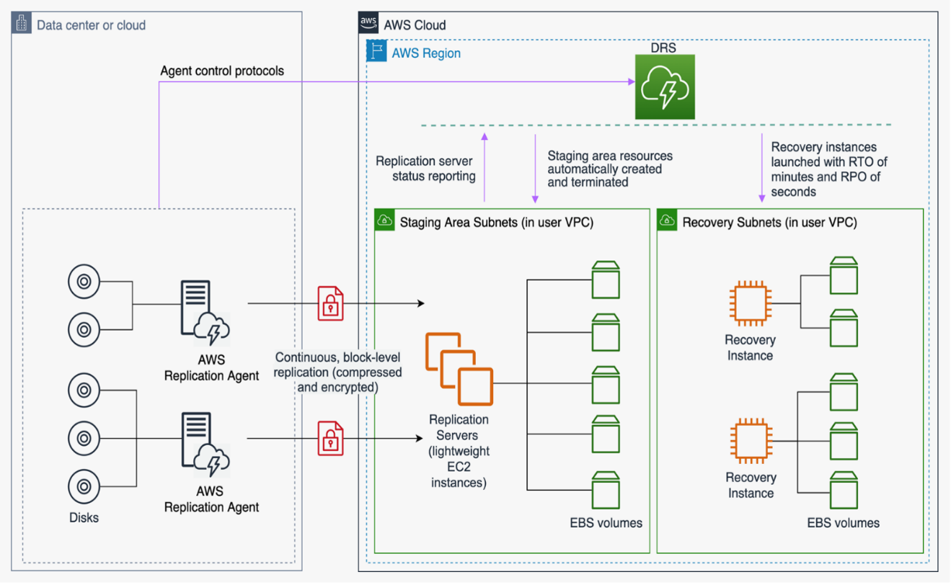

- Warm Standby
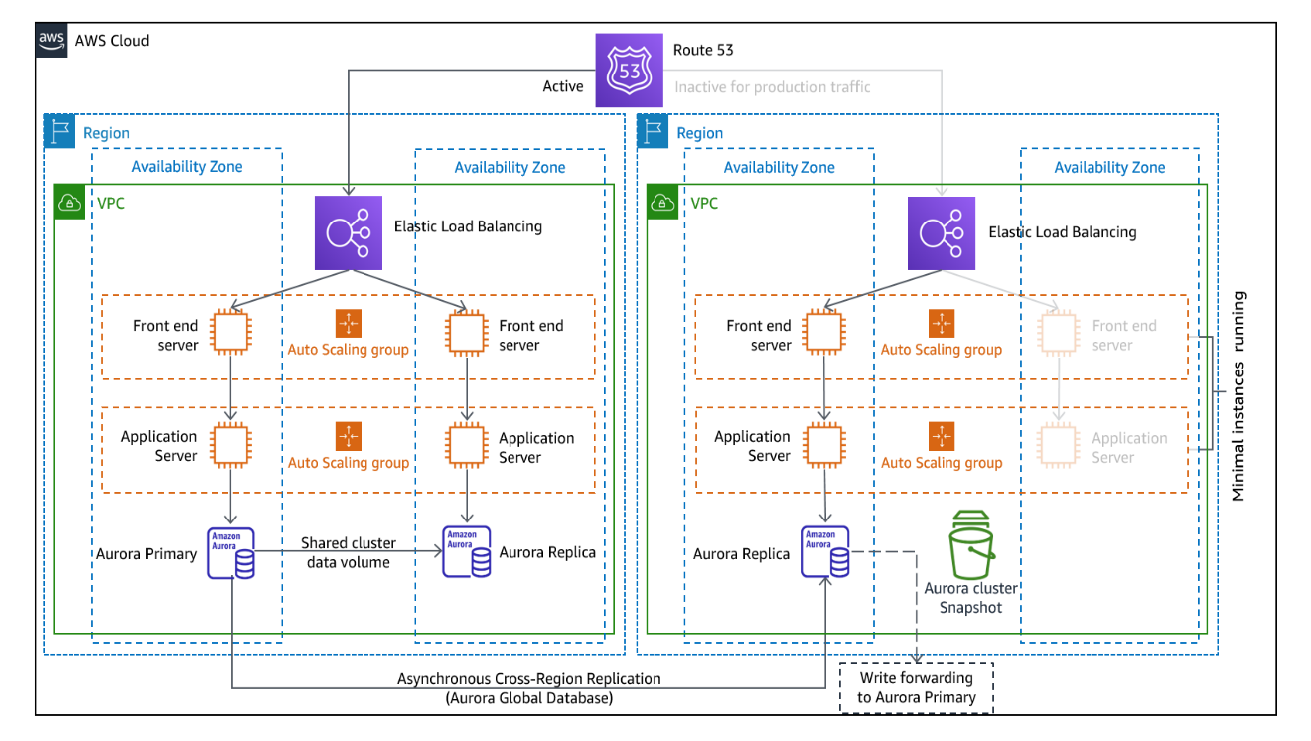
The warm standby approach involves ensuring that there is a scaled down, but fully functional, copy of your production environment in another Region. This approach extends the pilot light concept and decreases the time to recovery because your workload is always-on in another Region. This approach also allows you to more easily perform testing or implement continuous testing to increase confidence in your ability to recover from a disaster.

Note: The difference between pilot light and warm standby can sometimes be difficult to understand. Both include an environment in your DR Region with copies of your primary Region assets. The distinction is that pilot light cannot process requests without additional action taken first, whereas warm standby can handle traffic (at reduced capacity levels) immediately. The pilot light approach requires you to “turn on” servers, possibly deploy additional (non-core) infrastructure, and scale up, whereas warm standby only requires you to scale up (everything is already deployed and running). Use your RTO and RPO needs to help you choose between these approaches.
- AWS services
All of the AWS services covered under backup and restore and pilot light are also used in warm standby for data backup, data replication, active/passive traffic routing, and deployment of infrastructure including EC2 instances.
Amazon EC2 Auto Scaling is used to scale resources including Amazon EC2 instances, Amazon ECS tasks, Amazon DynamoDB throughput, and Amazon Aurora replicas within an AWS Region. Amazon EC2 Auto Scaling scales deployment of EC2 instance across Availability Zones within an AWS Region, providing resiliency within that Region. Use Auto Scaling to scale out your DR Region to full production capability, as part of a pilot light or warm standby strategies. For example, for EC2, increase the desired capacity setting on the Auto Scaling group. You can adjust this setting manually through the AWS Management Console, automatically through the AWS SDK, or by redeploying your AWS CloudFormation template using the new desired capacity value. You can use AWS CloudFormation parameters to make redeploying the CloudFormation template easier. Ensure that service quotas in your DR Region are set high enough so as to not limit you from scaling up to production capacity.
Because Auto Scaling is a control plane activity, taking a dependency on it will lower the resiliency of your overall recovery strategy. It is a trade-off. You can choose to provision sufficient capacity such that the recovery Region can handle the full production load as deployed. This statically stable configuration is called hot standby (see the next section). Or you may choose to provision fewer resources which will cost less, but take a dependency on Auto Scaling. Some DR implementations will deploy enough resources to handle initial traffic, ensuring low RTO, and then rely on Auto Scaling to ramp up for subsequent traffic.
- Multi-site active/active
You can run your workload simultaneously in multiple Regions as part of a multi-site active/active or hot standby active/passive strategy. Multi-site active/active serves traffic from all regions to which it is deployed, whereas hot standby serves traffic only from a single region, and the other Region(s) are only used for disaster recovery. With a multi-site active/active approach, users are able to access your workload in any of the Regions in which it is deployed. This approach is the most complex and costly approach to disaster recovery, but it can reduce your recovery time to near zero for most disasters with the correct technology choices and implementation (however data corruption may need to rely on backups, which usually results in a non-zero recovery point). Hot standby uses an active/passive configuration where users are only directed to a single region and DR regions do not take traffic. Most customers find that if they are going to stand up a full environment in the second Region, it makes sense to use it active/active. Alternatively, if you do not want to use both Regions to handle user traffic, then Warm Standby offers a more economical and operationally less complex approach.
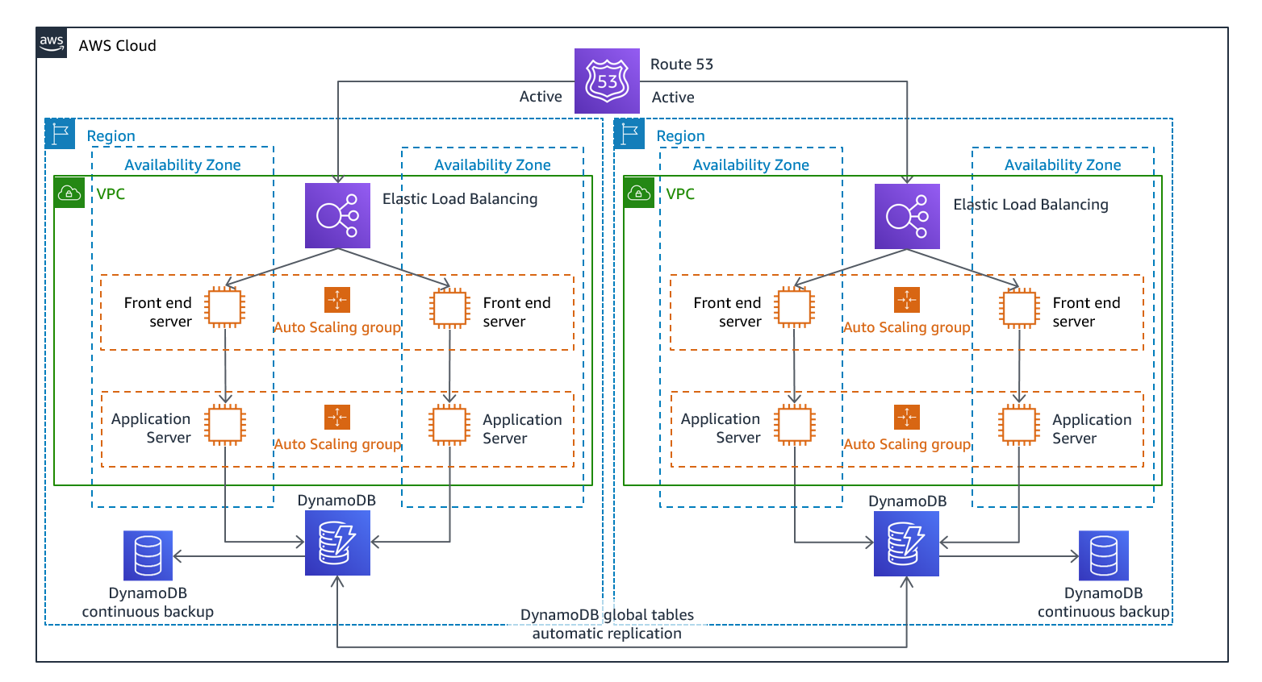
With multi-site active/active, because the workload is running in more than one Region, there is no such thing as failover in this scenario. Disaster recovery testing in this case would focus on how the workload reacts to loss of a Region: Is traffic routed away from the failed Region? Can the other Region(s) handle all the traffic? Testing for a data disaster is also required. Backup and recovery are still required and should be tested regularly. It should also be noted that recovery times for a data disaster involving data corruption, deletion, or obfuscation will always be greater than zero and the recovery point will always be at some point before the disaster was discovered. If the additional complexity and cost of a multi-site active/active (or hot standby) approach is required to maintain near zero recovery times, then additional efforts should be made to maintain security and to prevent human error to mitigate against human disasters.
- AWS services
All of the AWS services covered under backup and restore, pilot light, and warm standby also are used here for point-in-time data backup, data replication, active/active traffic routing, and deployment and scaling of infrastructure including EC2 instances.
For the active/passive scenarios discussed earlier (Pilot Light and Warm Standby), both Amazon Route 53 and AWS Global Accelerator can be used for route network traffic to the active region. For the active/active strategy here, both of these services also enable the definition of policies that determine which users go to which active regional endpoint. With AWS Global Accelerator you set a traffic dial to control the percentage of traffic that is directed to each application endpoint. Amazon Route 53 supports this percentage approach, and also multiple other available policies including geoproximity and latency based ones. Global Accelerator automatically leverages the extensive network of AWS edge servers, to onboard traffic to the AWS network backbone as soon as possible, resulting in lower request latencies.
Asynchronous data replication with this strategy enables near-zero RPO. AWS services like Amazon Aurora global database use dedicated infrastructure that leaves your databases entirely available to serve your application, and can replicate to up to five secondary Region with typical latency of under a second. With active/passive strategies, writes occur only to the primary Region. The difference with active/active is designing how data consistency with writes to each active Region is handled. It is common to design user reads to be served from the Region closest to them, known as read local. With writes, you have several options:
- A write global strategy routes all writes to a single Region. In case of failure of that Region, another Region would be promoted to accept writes. Aurora global database is a good fit for write global, as it supports synchronization with read-replicas across Regions, and you can promote one of the secondary Regions to take read/write responsibilities in less than one minute. Aurora also supports write forwarding, which lets secondary clusters in an Aurora global database forward SQL statements that perform write operations to the primary cluster.
- A write local strategy routes writes to the closest Region (just like reads). Amazon DynamoDB global tables enables such a strategy, allowing read and writes from every region your global table is deployed to. Amazon DynamoDB global tables use a last writer wins reconciliation between concurrent updates.
- A write partitioned strategy assigns writes to a specific Region based on a partition key (like user ID) to avoid write conflicts. Amazon S3 replication configured bi-directionally can be used for this case, and currently supports replication between two Regions. When implementing this approach, make sure to enable replica modification sync on both buckets A and B to replicate replica metadata changes like object access control lists (ACLs), object tags, or object locks on the replicated objects. You can also configure whether or not to replicate delete markers between buckets in your active Regions. In addition to replication, your strategy must also include point-in-time backups to protect against data corruption or destruction events.
Testing disaster recovery
Test disaster recovery implementation to validate the implementation and regularly test failover to your workload’s DR Region to ensure that RTO and RPO are met.
A pattern to avoid is developing recovery paths that are rarely executed. For example, you might have a secondary data store that is used for read-only queries. When you write to a data store and the primary fails, you might want to fail over to the secondary data store. If you don’t frequently test this failover, you might find that your assumptions about the capabilities of the secondary data store are incorrect. The capacity of the secondary, which might have been sufficient when you last tested, might no longer be able to tolerate the load under this scenario, or service quotas in the secondary Region might not be sufficient.
Our experience has shown that the only error recovery that works is the path you test frequently. This is the reason why having a small number of recovery paths is best.
You can establish recovery patterns and regularly test them. If you have a complex or critical recovery path, you still need to regularly execute that failure in production to validate that the recovery path works.
Manage configuration drift at the DR Region. Ensure that your infrastructure, data, and configuration are as needed at the DR Region. For example, check that AMIs and service quotas are up-to-date.
You can utilize AWS Config to continuously monitor and record your AWS resource configurations. AWS Config can detect drift and trigger AWS Systems Manager Automation to fix drift and raise alarms. AWS CloudFormation can additionally detect drift in stacks you have deployed.
Conclusion
Customers are responsible for the availability of their applications in the cloud. It is important to define what a disaster is and to have a disaster recovery plan that reflects this definition and the impact that it may have on business outcomes. Create Recovery Time Objective (RTO) and Recovery Point Objective (RPO) based on impact analysis and risk assessments and then choose the appropriate architecture to mitigate against disasters. Ensure that detection of disasters is possible and timely — it is vital to know when objectives are at risk. Ensure you have a plan and validate the plan with testing. Disaster recovery plans that have not been validated risk not being implemented due to a lack of confidence or failure to meet disaster recovery objectives.

